**IRIS API**

**Adding Archetype in Design Studio:**

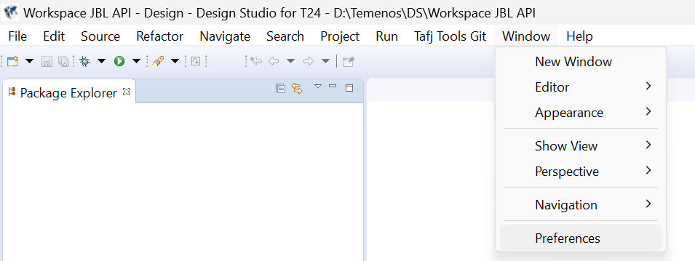



**Window > Preferences > Archetypes > Add Local Catalog**

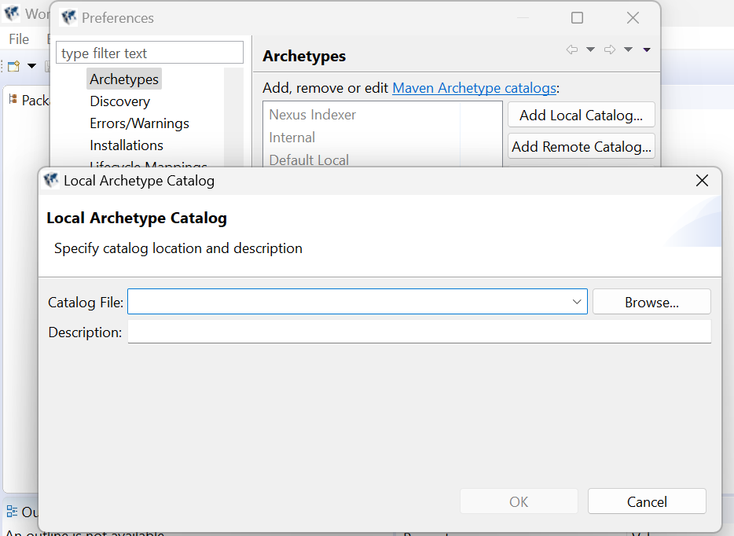



**T24-binaries > D:\Temenos\DS\t24-binaries -- archetype-catalog.xml**

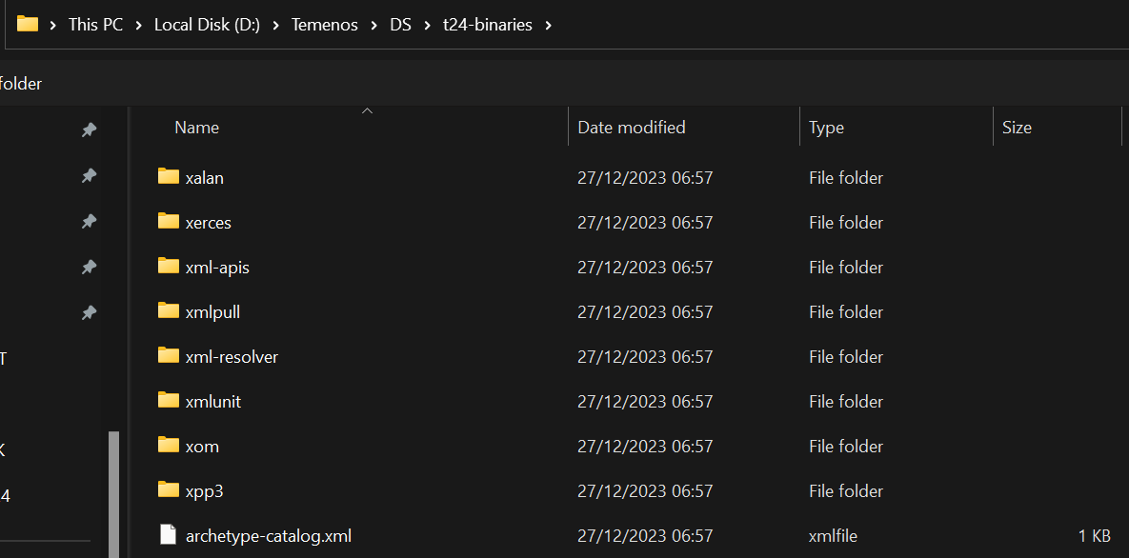



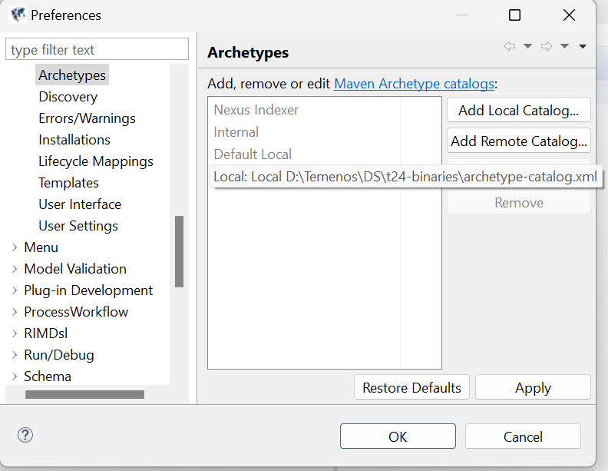



**New Mavel Project from DS:**

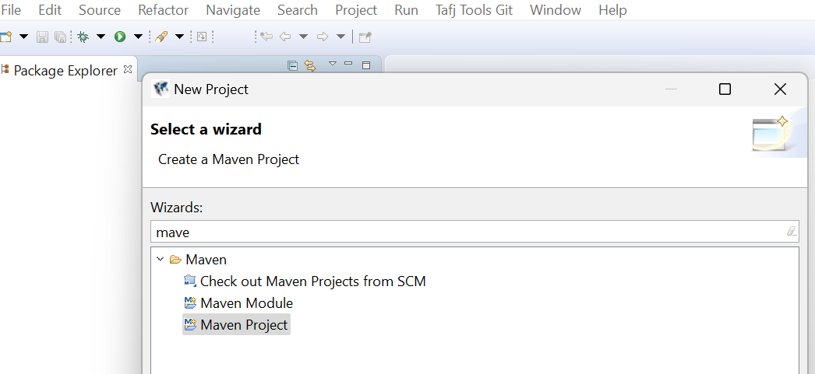



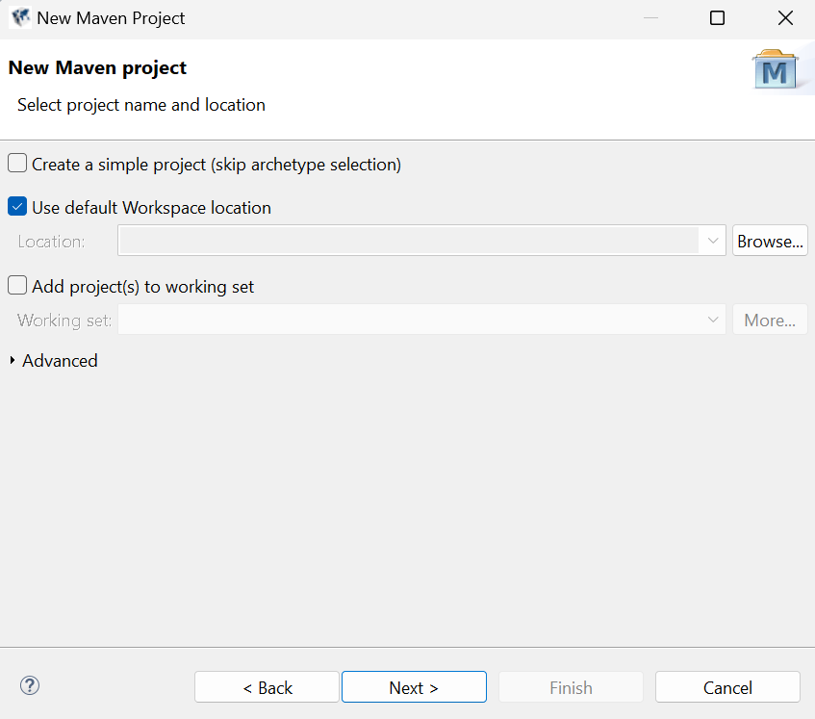



There must be two **Maven** Projects (irf-service-archetype & irf-service-container -archetype)

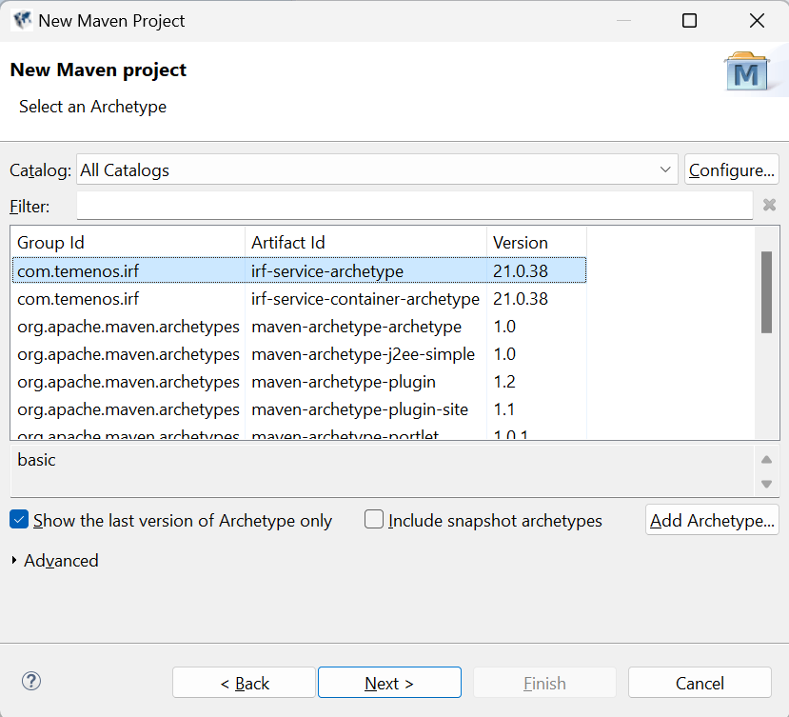



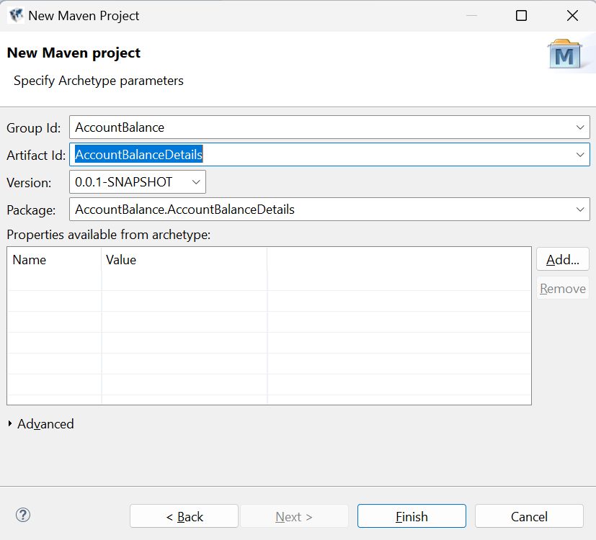



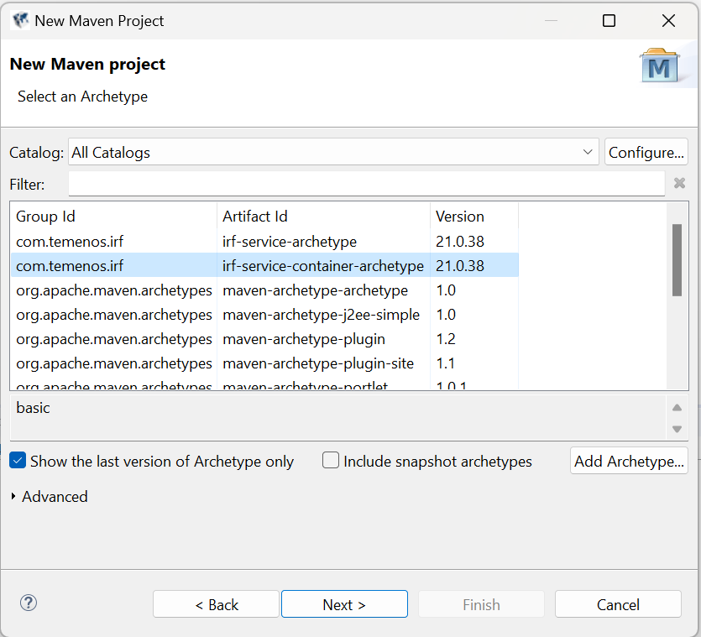



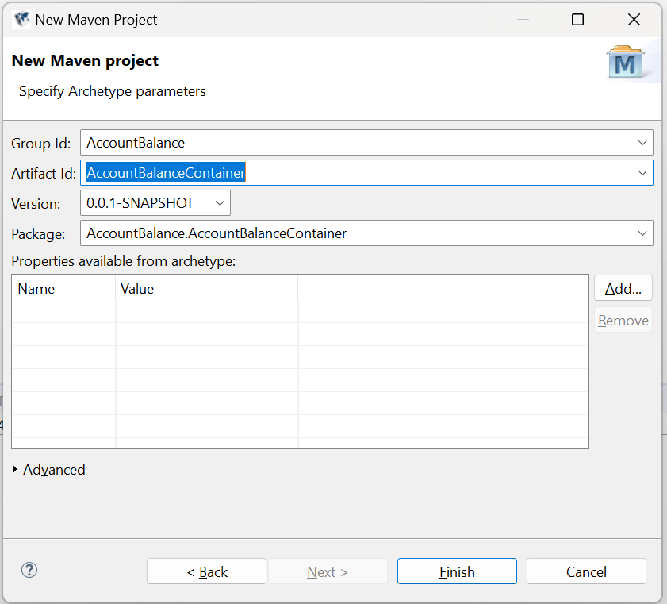



**Clean the both container and Service project by Selecting,**

**Right click on Project → Run As → Maven Clean.**

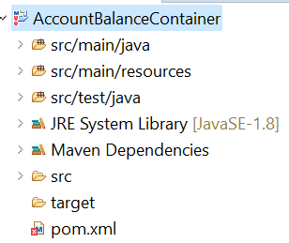

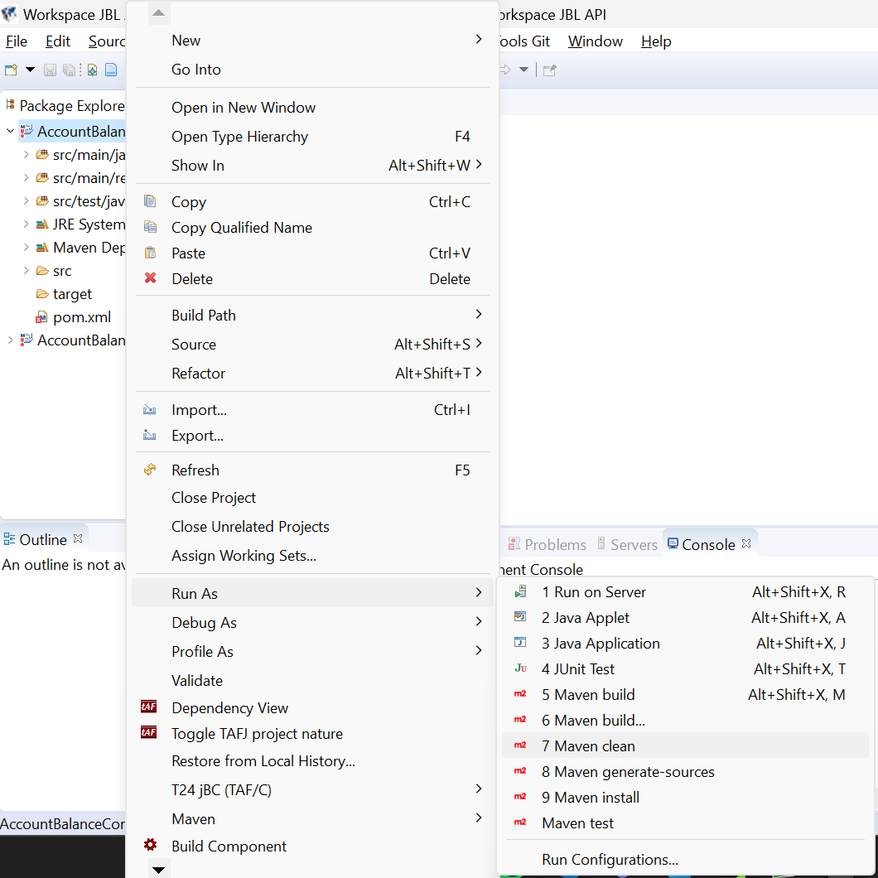

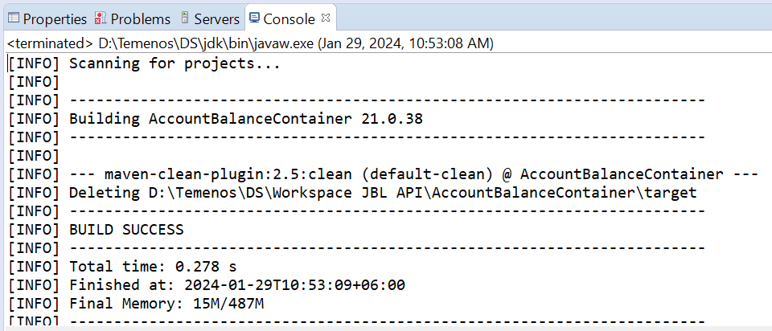

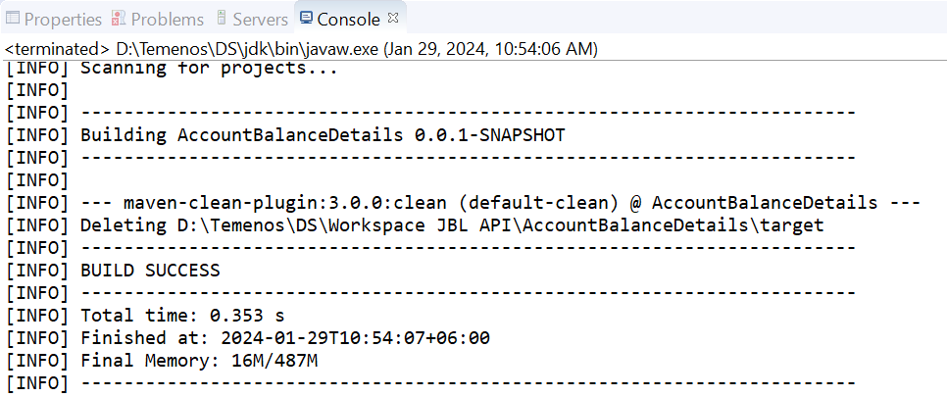

***IRIS 2.0 war File Generation***

Deploy the 2 war files which is given by temenos in your JBoss

**irf-web-client - Workbench**

**irf-test-web - To test the IRIS Services**

Give the base URL in the browser-> Workbench gets opened…

 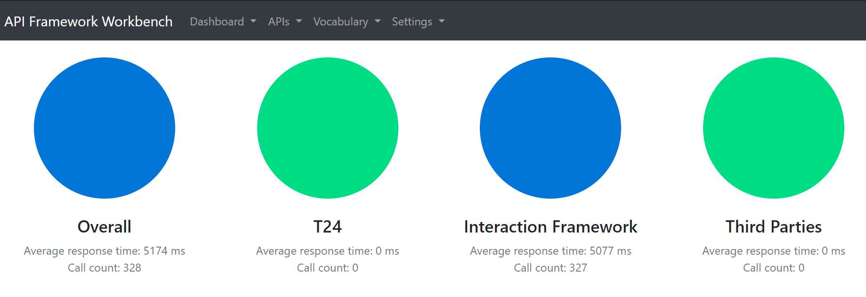







**Select settings tab → click settings → Then the servers page gets opened.**

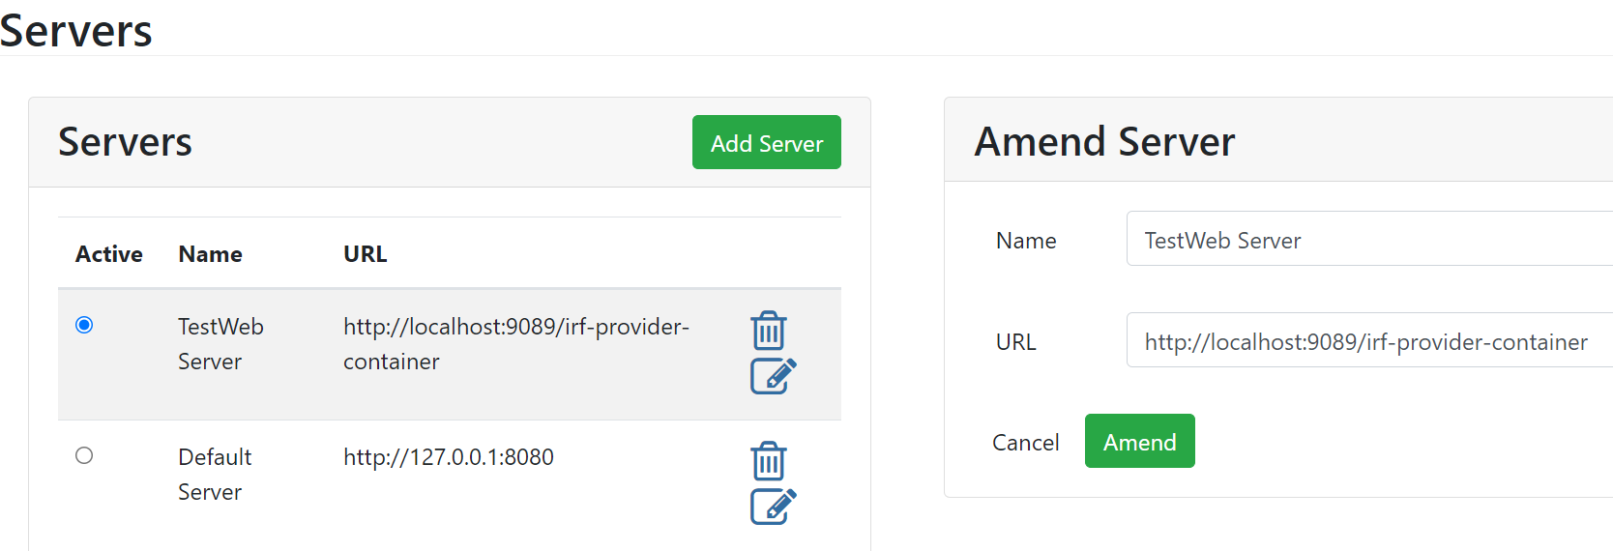



**API Creation from Workbench**

**API Creation:**   
First We should create a Version or Enquiry in below format.  
**Product.API.verb.version** -----EX: ST.API.CUSTOMERS.1.0.0

go to localhost:9089/irf-web-client  
Click API>create provider API.

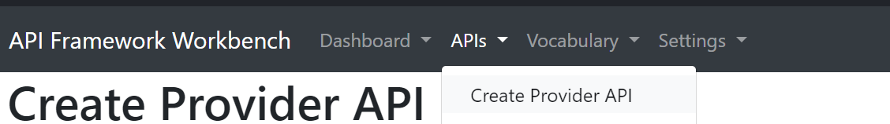



The Available Artefacts can be displayed. The Artefacts can be Versions(Screen), Enquiries(Query),AA Product(Product) and so on.

***Select the data’s which you want to import.***

***The API definition page will be displayed.***  
Select the required artefacts from available artefacts.

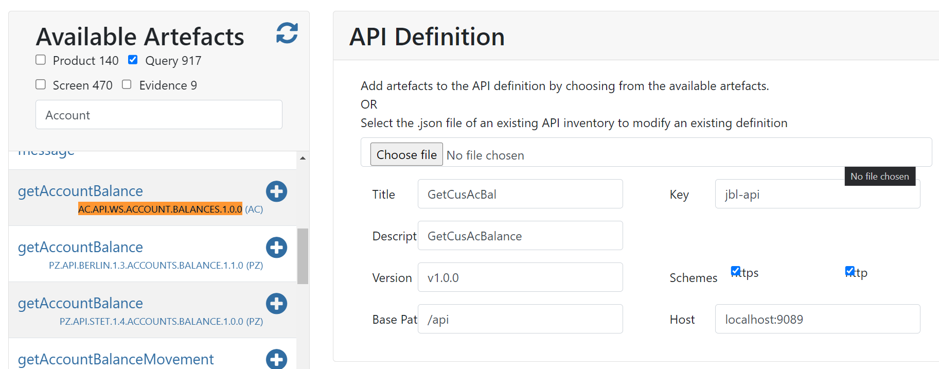

Provide key , url, summary, description. (**give request and response payload versions If it is AA API**)

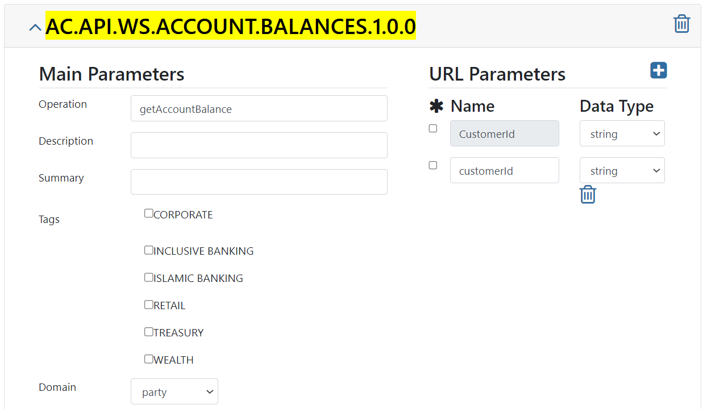

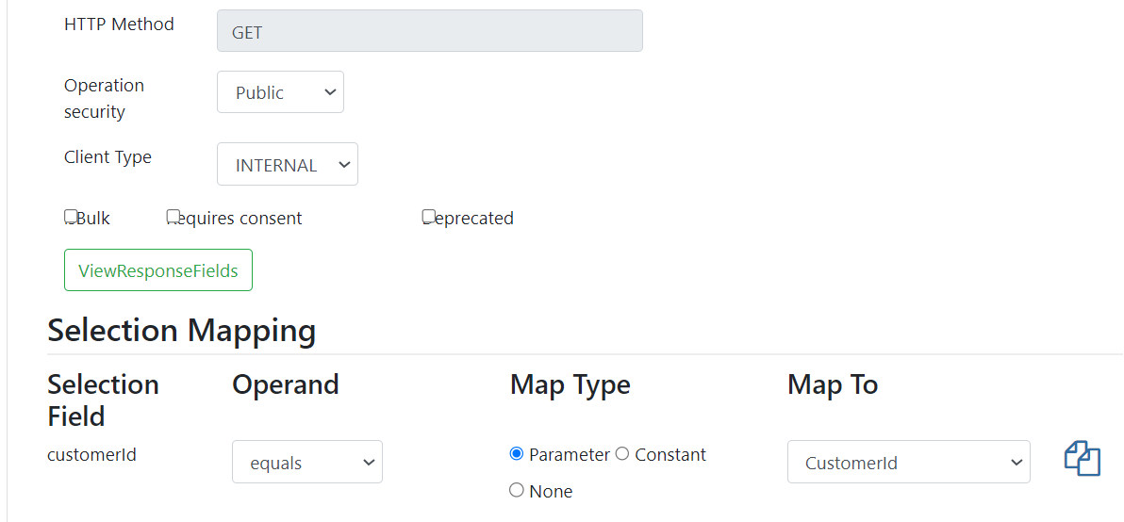  
click **NEXT** on top of the screen>**FINISH**

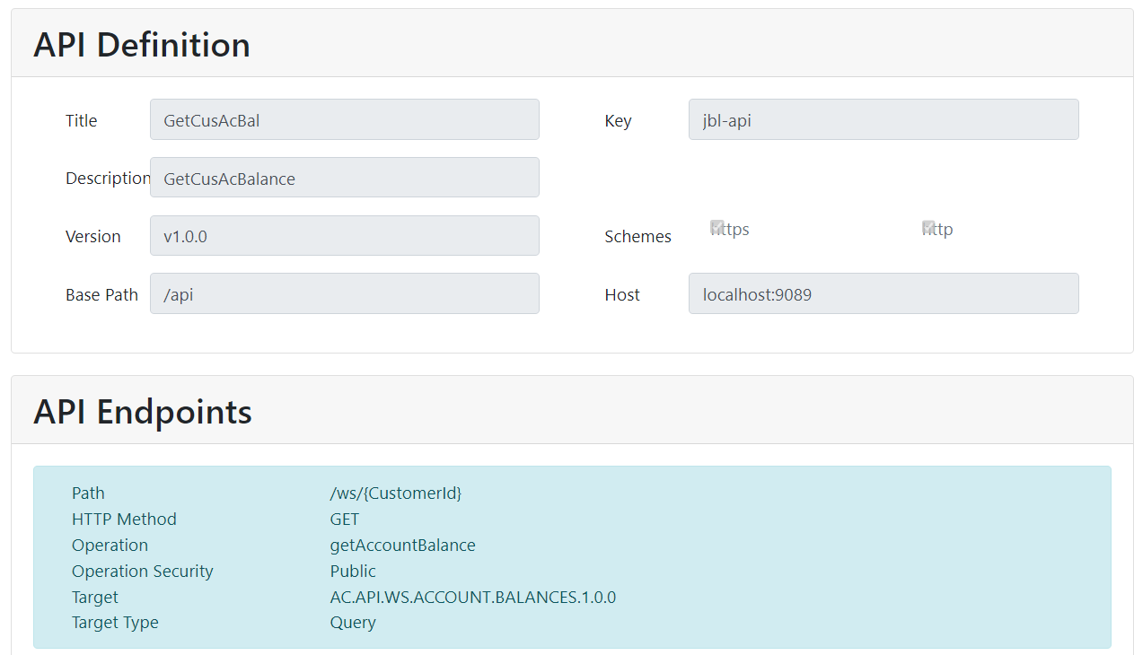  
  
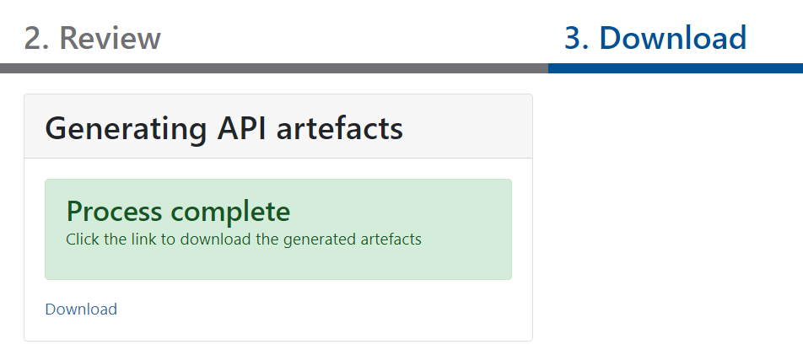 IRIS Workbench will generate a zip based on selected transact artefacts. Download it.  
That zip contains 3 folders. **i.e. api-docs, inventory, services**

After creating a **Maven** project (**AccountBalanceDetails**),  
Delete all files in src/main/resources  
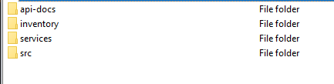  
**api-docs** – This folder contains swagger which will show the specification of our API  
**Ex**:

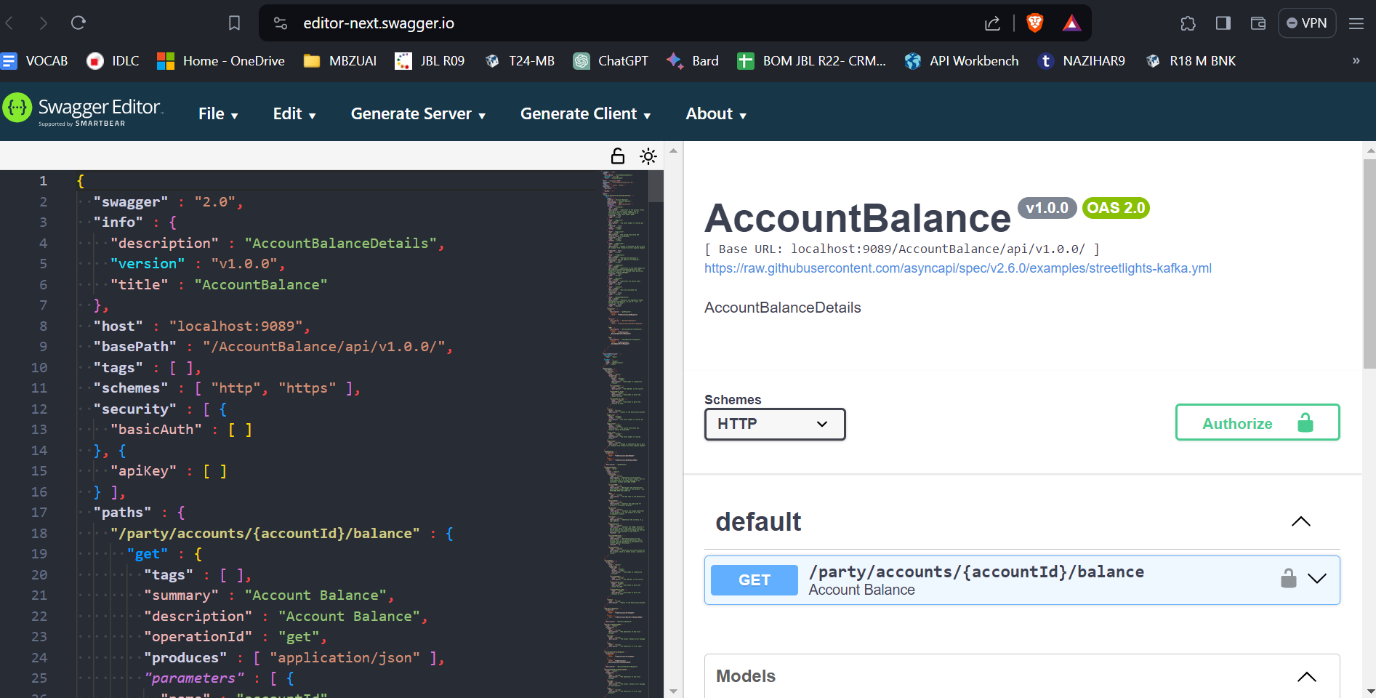

**Inventory** – This folder contains details of the generated artefacts/APIs. Which is useful to load existing APIs to the workbench rather than selecting artefacts from scratch.

**Services**- This folder contains the xml routes for routing the API to appropriate transact artefact.

This file alone is fine to deploy in a container to get our API work.

Paste the **Downloaded** files from the **Workbench** in the Below path,

**D:\Temenos\DS\Workspace JBL API\AccountBalanceDetails\src\main\resources**

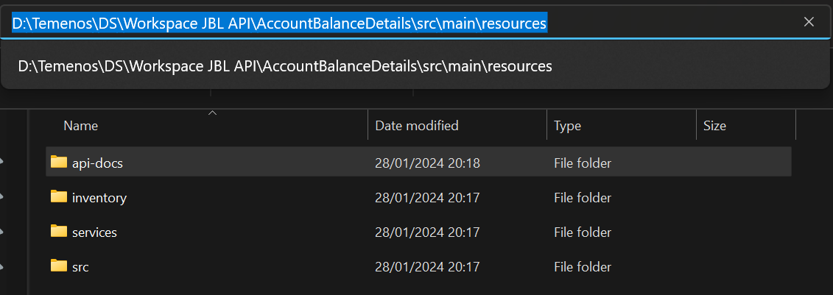

Right click on the main project(**AccountBalanceDetails**)>Run as> **Maven build**…>clean install> run (Musk check **Skip Tests**)

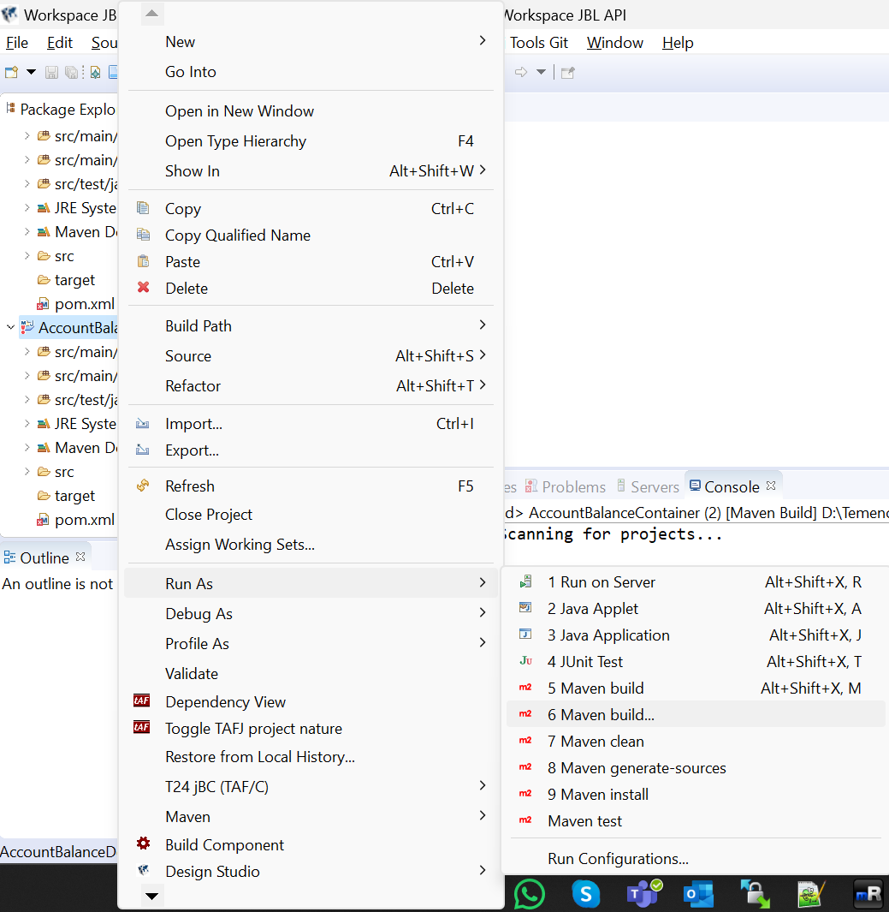



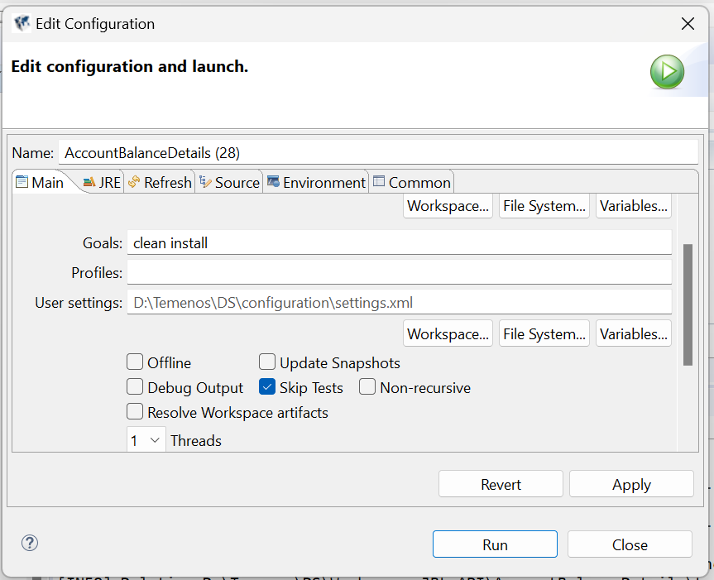



If the BUILD is FAILED then need to download the .jar  file and paste it inside the **t24 binaries** directory like this,

**D:\Temenos\DS\t24-binaries\org\json\json\20170516**

We also need to replace each http to https in **archetype-catalog.xml** file.

If the **BUILD** is **SUCCESSFUL** then the **jar** file will be created here.

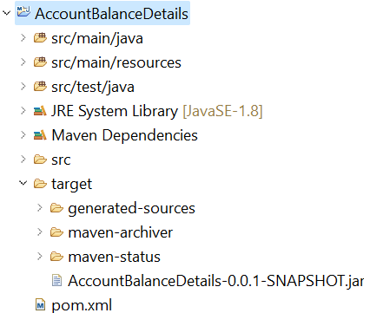



Go to the **container** project >pom.xml  
Go to **dependencies** tab and add your jars (created in main project)

Go to **pom.xml** tab

buildforJMS > true ; Not Required/Optional for Model Bank.

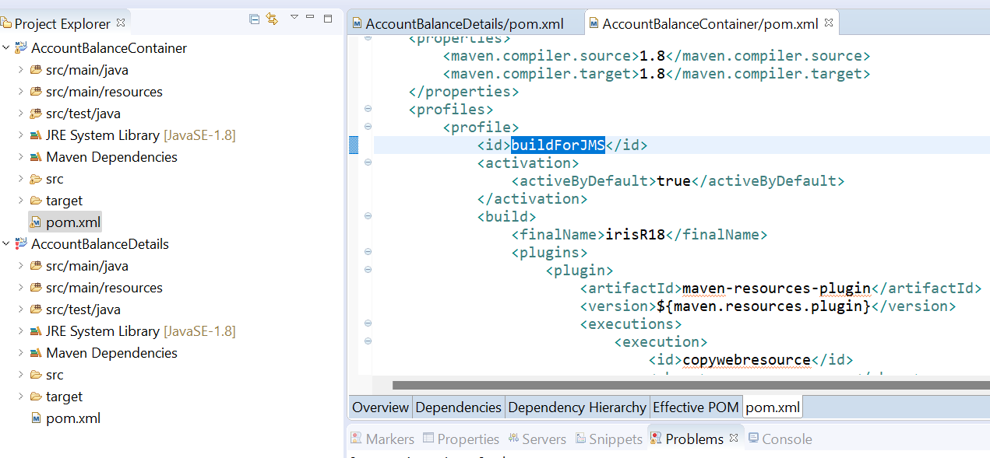

**Adding Dependencies:**

**Special Note:** We must build the main project first then the container project.

Double click on pom.xml → select Dependencies tab → click Add.

The **container** will have the main project **jar file** as a Dependency.

Search your service name in Enter **groupId** field → select your service → Click **OK**.

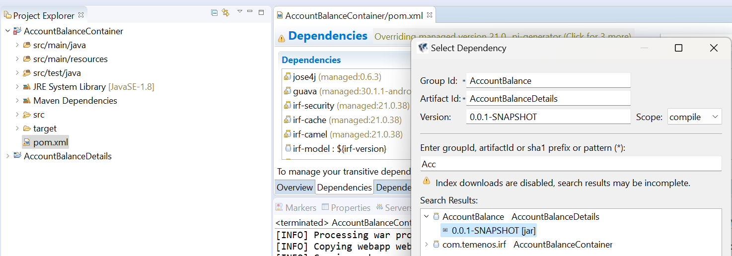



Then **Save** it. → Ctrl +S

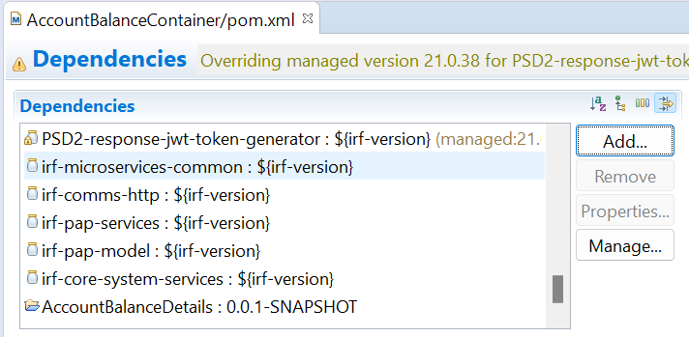



If the jboss is a remote server then,

Provide the jboss environment: username and password.

Java.naming.security.principal = username

Java.naming.security.credentials = Password

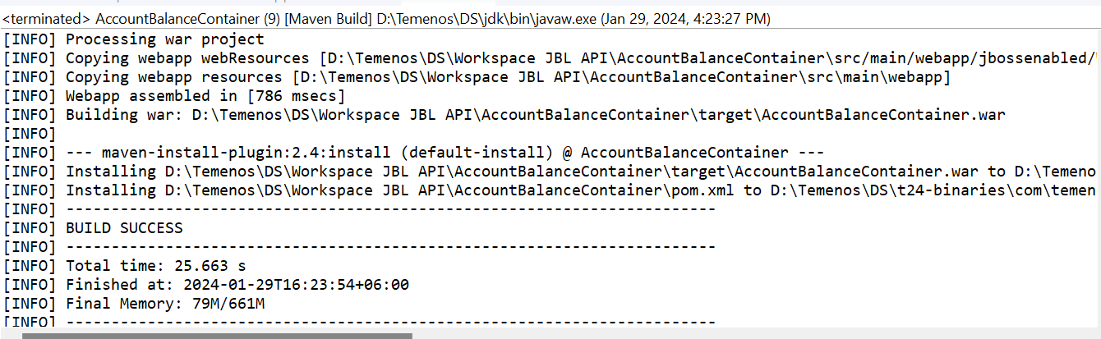



**D:\Temenos\DS\Workspace JBL API\AccountBalanceContainer\target**

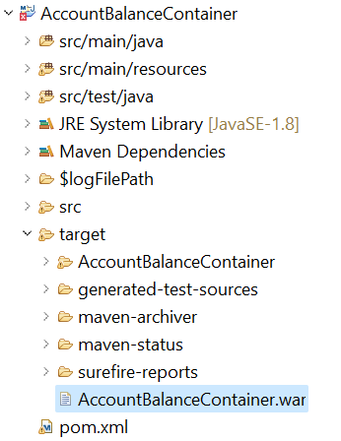

**To Enable/disable xacml:**

**Comment** out below line to disable xacml. (OR) **Uncomment** to enable xacml.

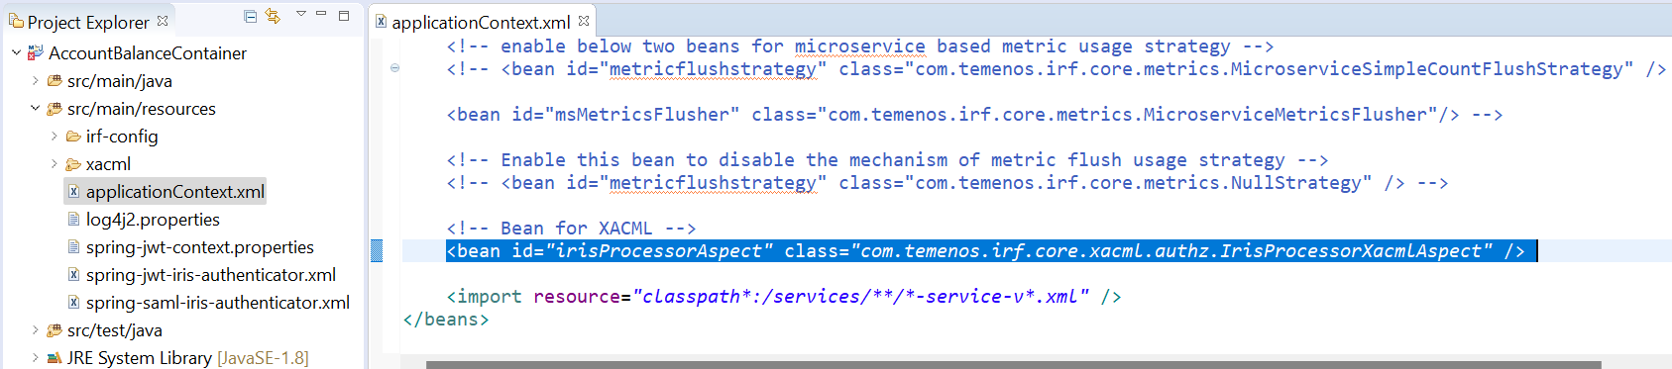



**To Enable/disable JWT:**

**Comment** out below set of lines to disable JWT (OR)

**UnComment** below set of lines to enable JWT.

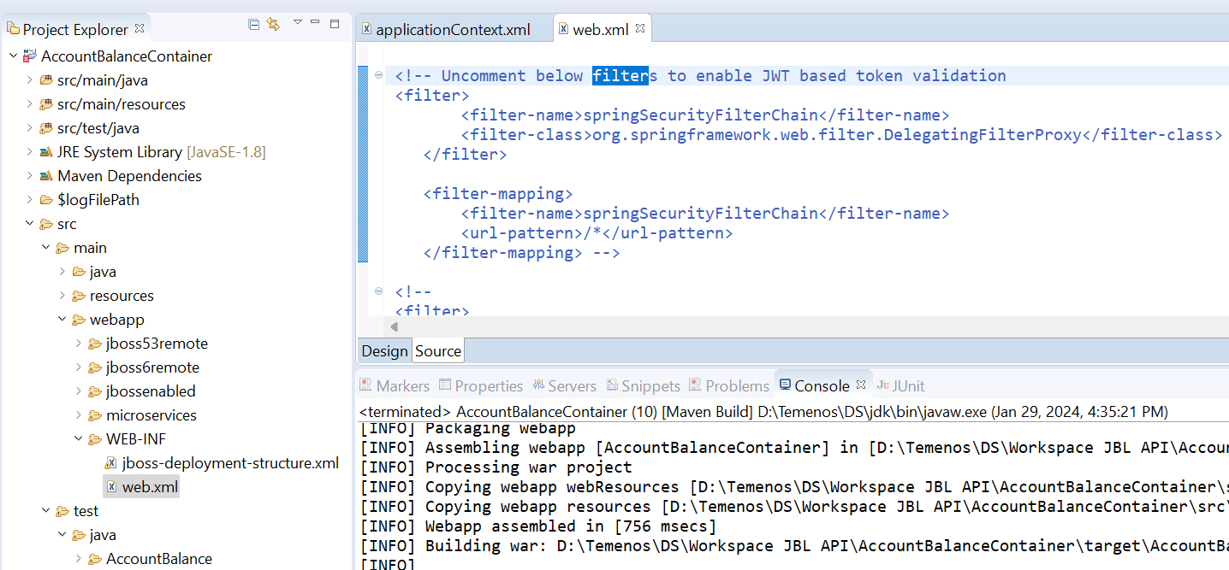



If **jms.properties** is required to change from the war file,

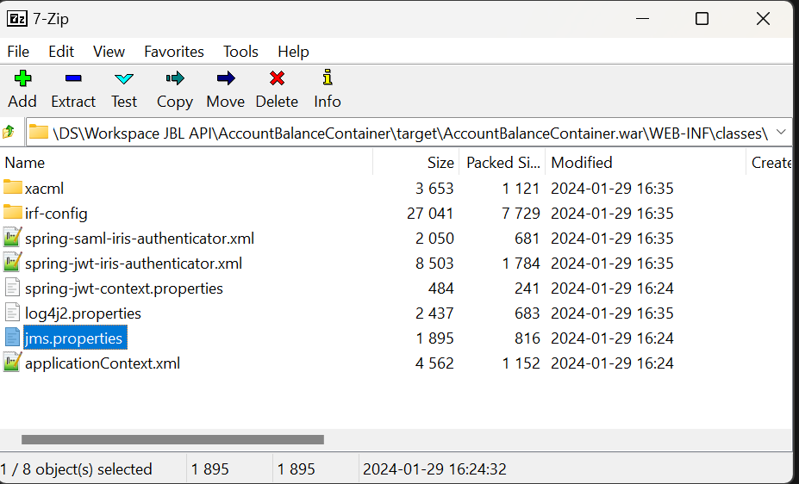

**Deployment *:***

Deploy the .war file in your jboss. **D:\Temenos\jboss\standalone\deployments**

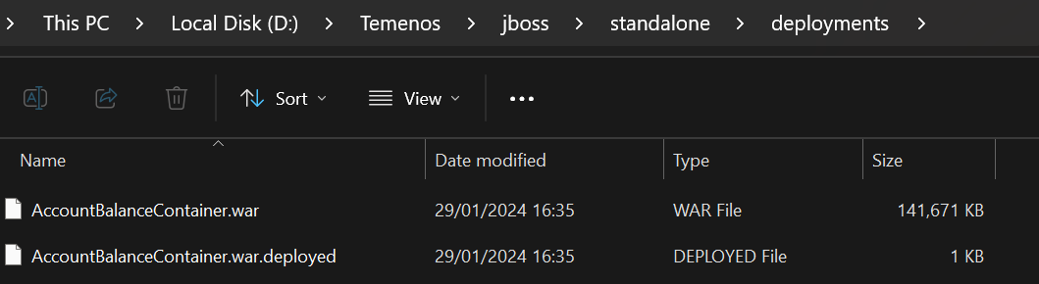

**Adding server to view the API :**

**Open workbench → click on Settings tab → click Add Server button.**

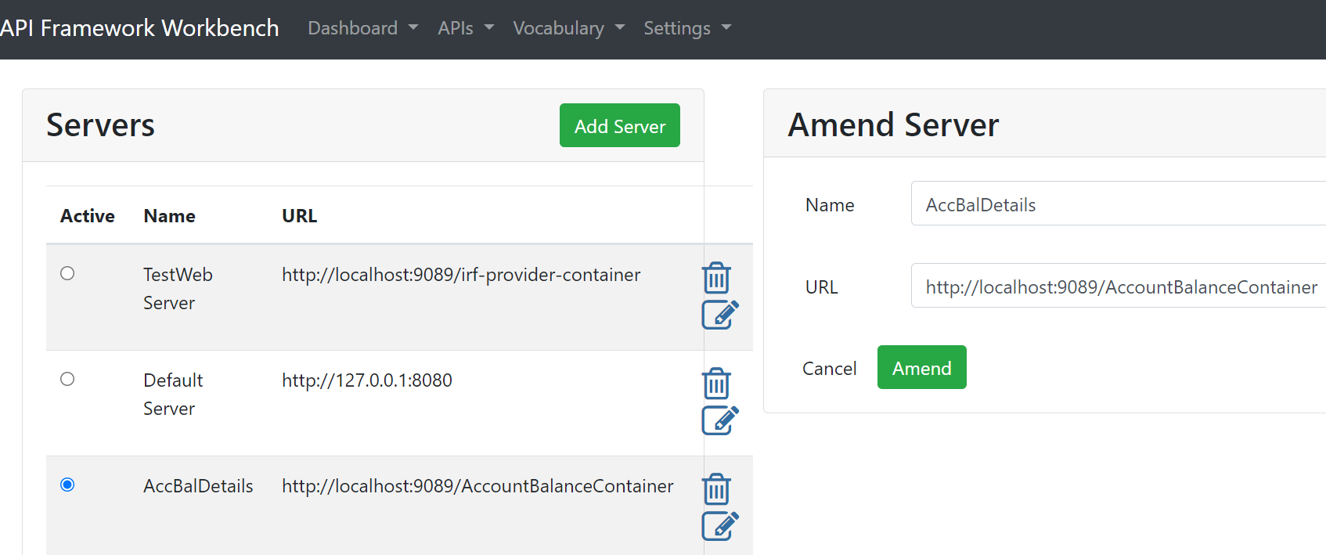



**Checking the Deployed Services**



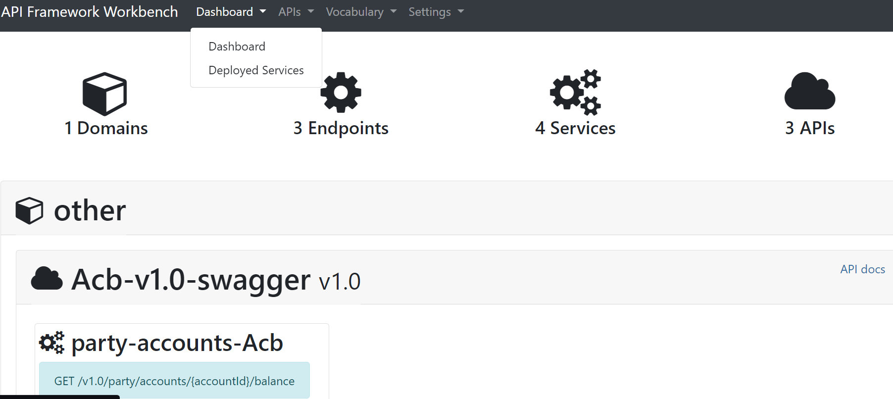



**CLICK - API docs**

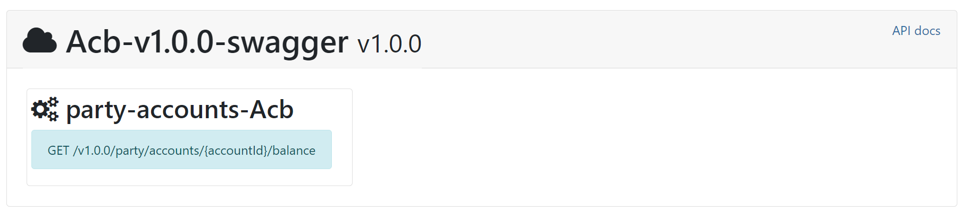



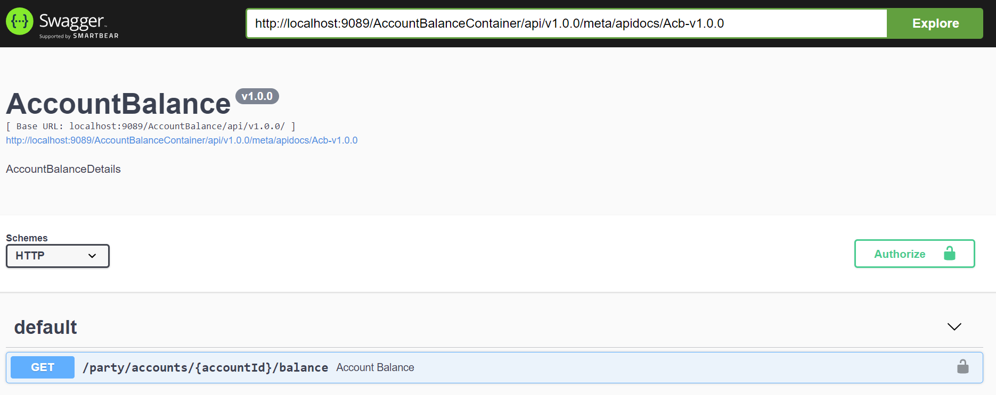

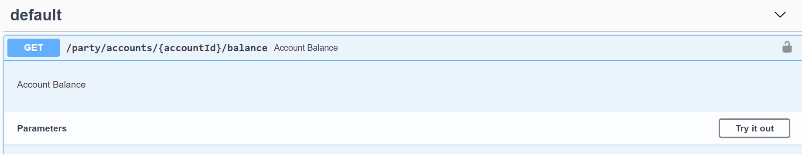



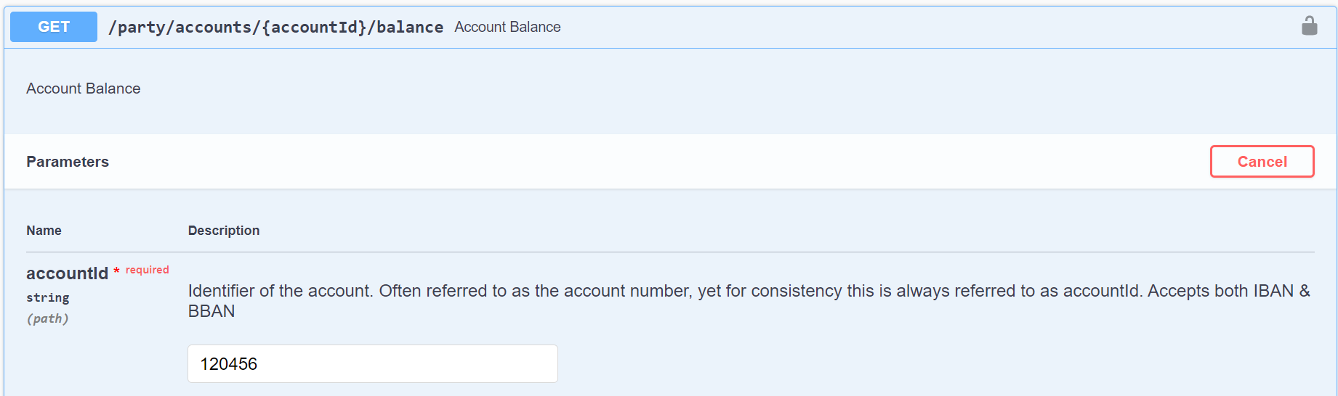



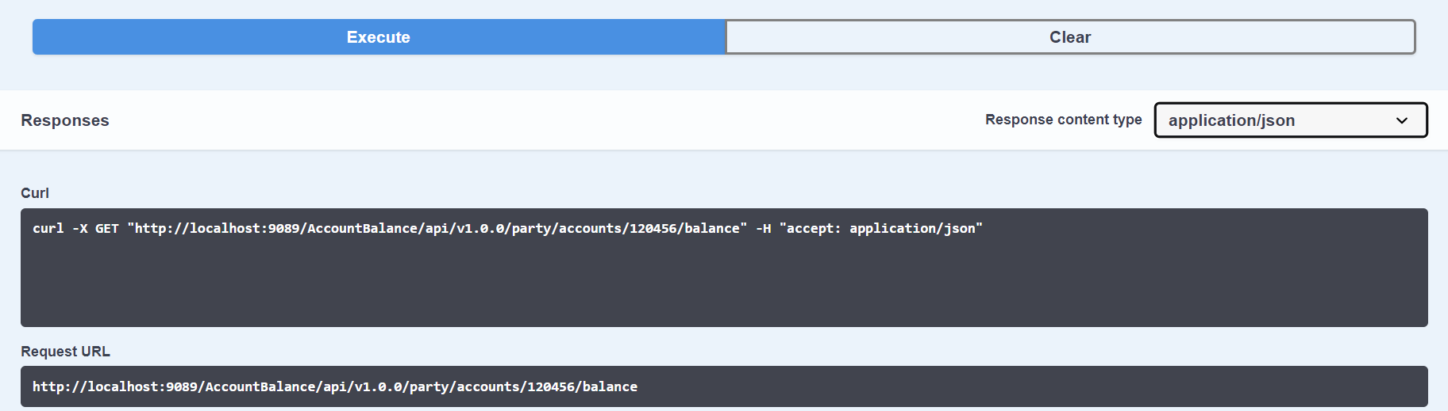



**Checking API in Postman:**

**Run postman → click ‘+’ button → paste your API link and add War filename in the link.**

**Click Send → Response will be shown.**

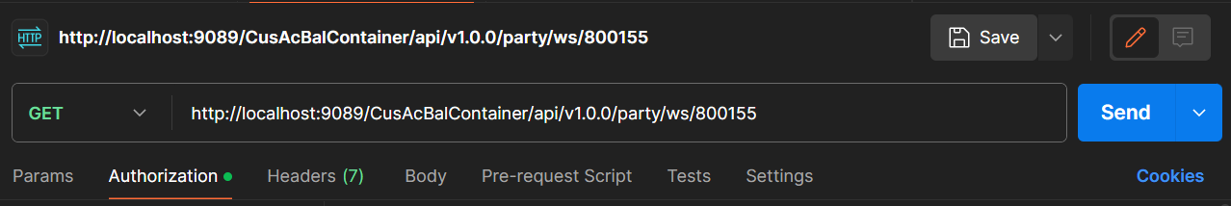



If authentication(Basic Auth) error is found then **applicationContext.xml file** need to be changed.

**Commend out** these lines:

<!-- <bean id="t24SecurityFilter" class="com.temenos.irf.comms.security.defaultimpl.NullBean" /> -->

<!-- <bean id="irisProcessorAspect" class="com.temenos.irf.core.xacml.authz.IrisProcessorXacmlAspect" /> -->

**Uncomment**:

<bean id="t24SecurityFilter" class="com.temenos.irf.comms.security.defaultimpl.T24BasicAuthenticationCheck" />

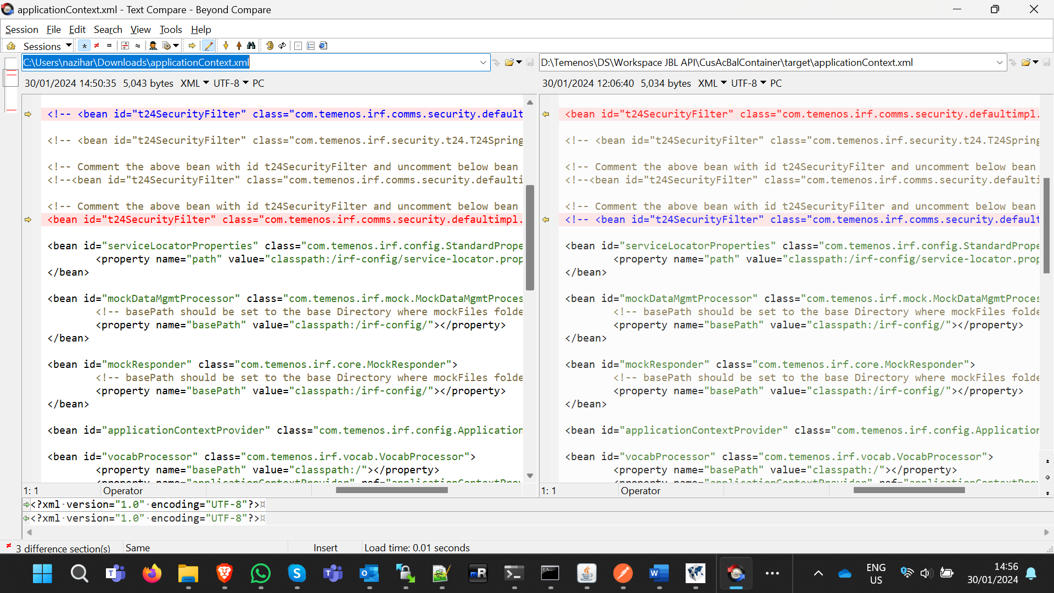

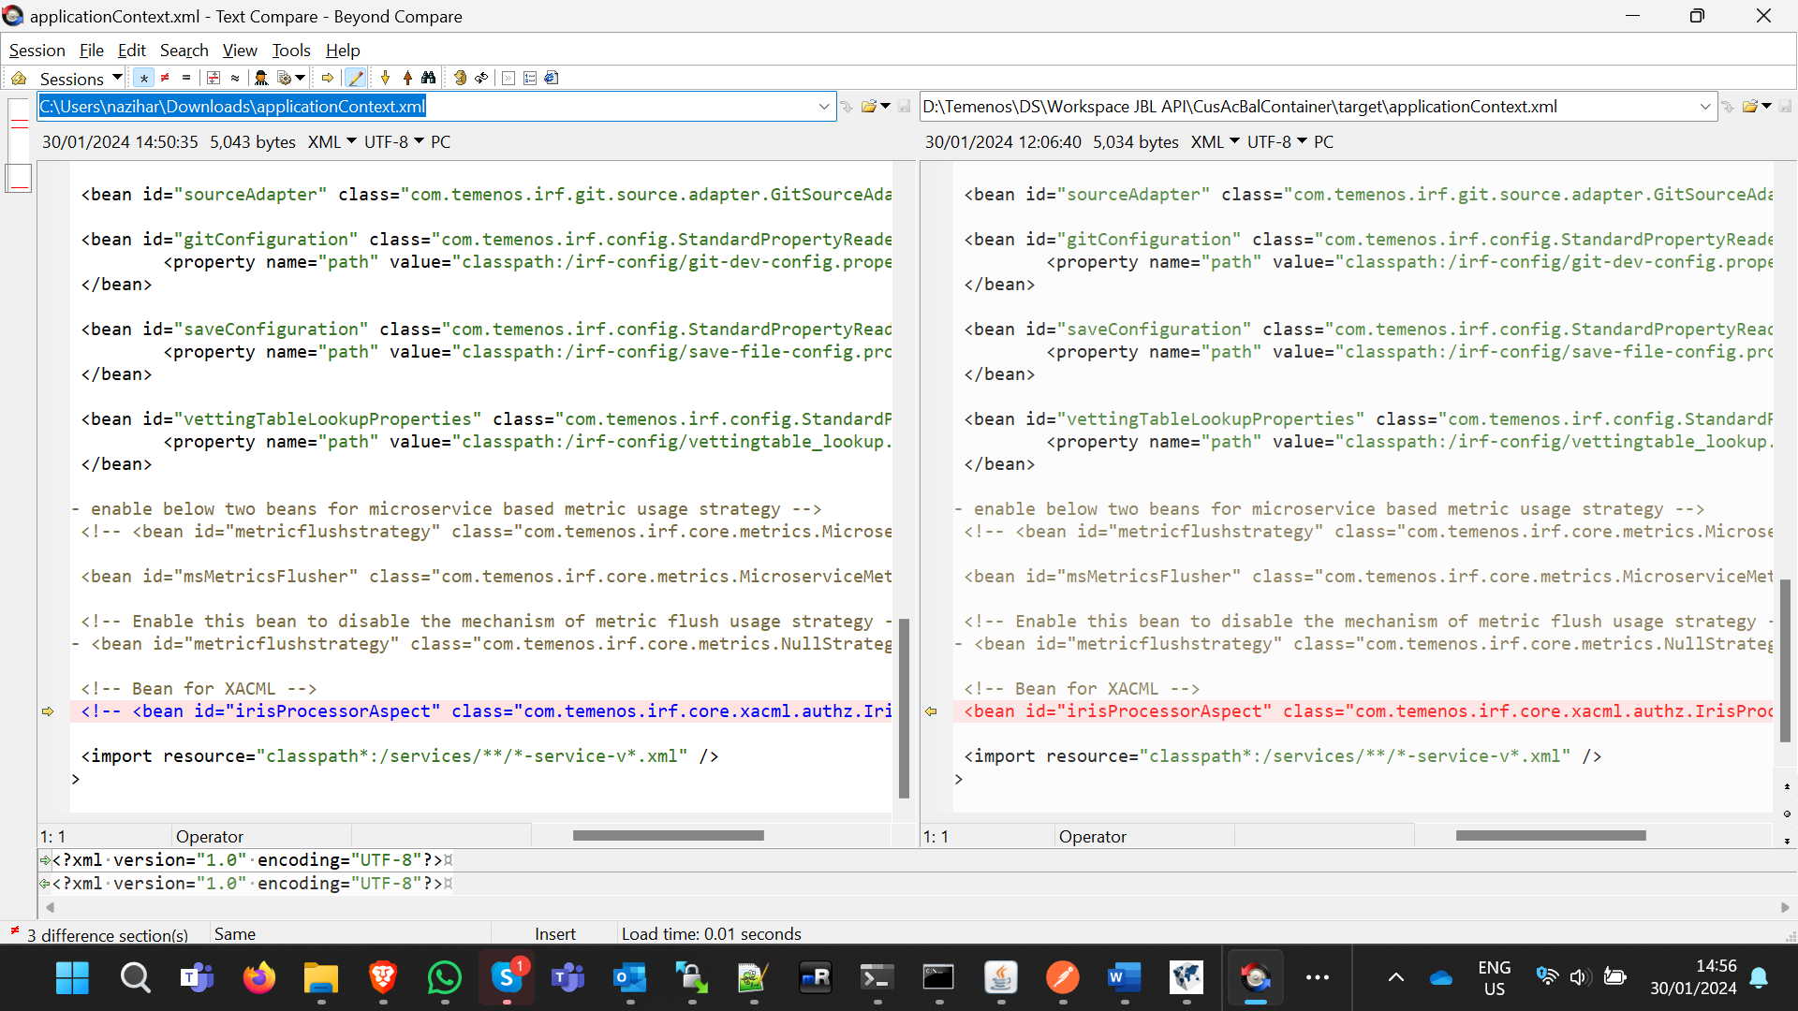

After changing and replacing the file in the war file it works!

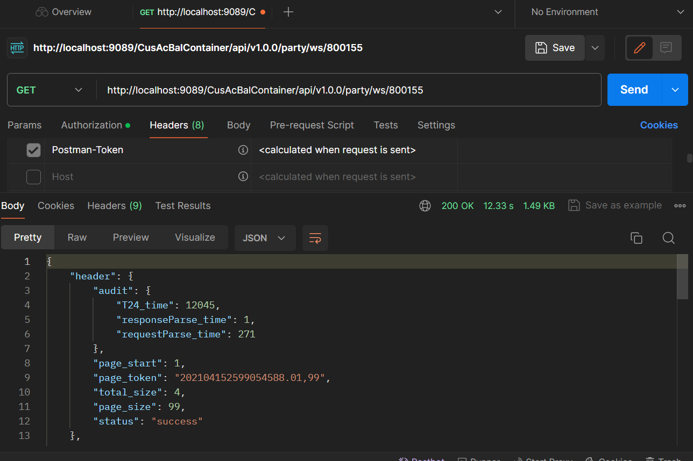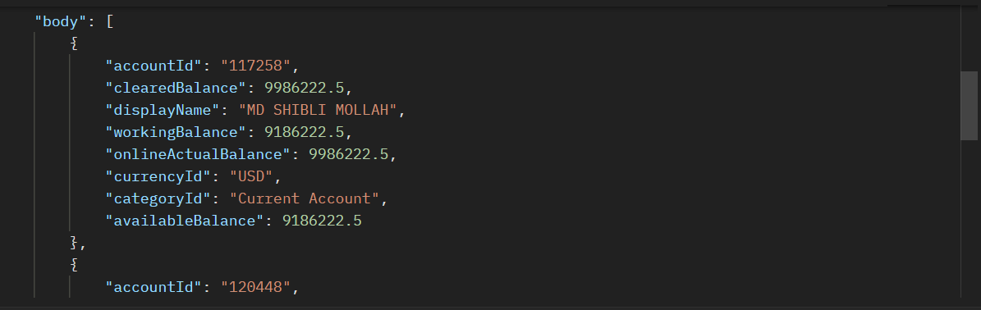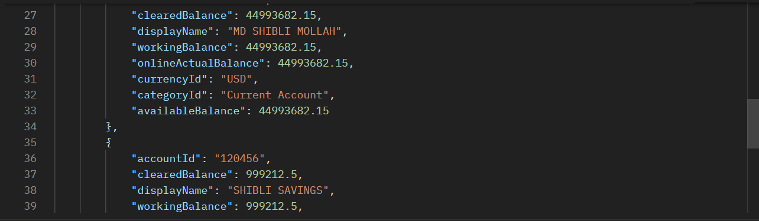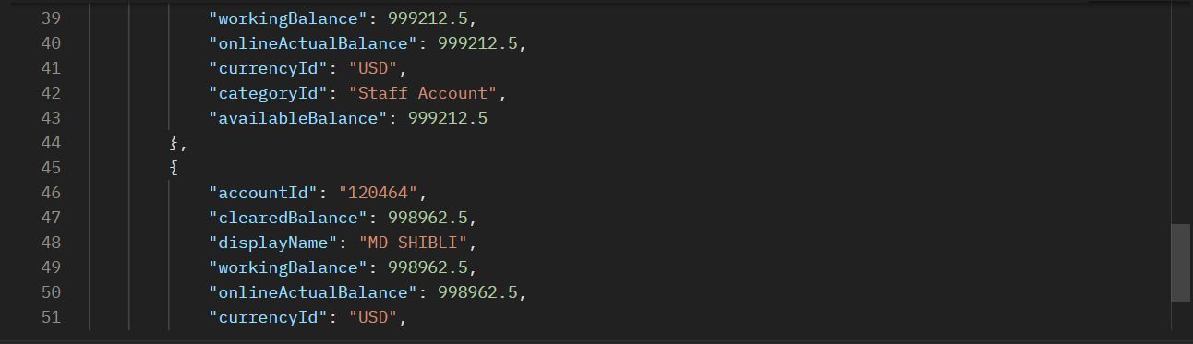

**Response:**

{

"header": {

"audit": {

"T24_time": 12045,

"responseParse_time": 1,

"requestParse_time": 271

},

"page_start": 1,

"page_token": "202104152599054588.01,99",

"total_size": 4,

"page_size": 99,

"status": "success"

},

"body": [

{

"accountId": "117258",

"clearedBalance": 9986222.5,

"displayName": "MD SHIBLI MOLLAH",

"workingBalance": 9186222.5,

"onlineActualBalance": 9986222.5,

"currencyId": "USD",

"categoryId": "Current Account",

"availableBalance": 9186222.5

},

{

"accountId": "120448",

"clearedBalance": 44993682.15,

"displayName": "MD SHIBLI MOLLAH",

"workingBalance": 44993682.15,

"onlineActualBalance": 44993682.15,

"currencyId": "USD",

"categoryId": "Current Account",

"availableBalance": 44993682.15

},

{

"accountId": "120456",

"clearedBalance": 999212.5,

"displayName": "SHIBLI SAVINGS",

"workingBalance": 999212.5,

"onlineActualBalance": 999212.5,

"currencyId": "USD",

"categoryId": "Staff Account",

"availableBalance": 999212.5

},

{

"accountId": "120464",

"clearedBalance": 998962.5,

"displayName": "MD SHIBLI",

"workingBalance": 998962.5,

"onlineActualBalance": 998962.5,

"currencyId": "USD",

"categoryId": "Savings Acct",

"availableBalance": 998962.5

}

]

}

**VERSION - POST**

Api creation and war file creation is almost same as the process for ENQUIRY.

POST request format:

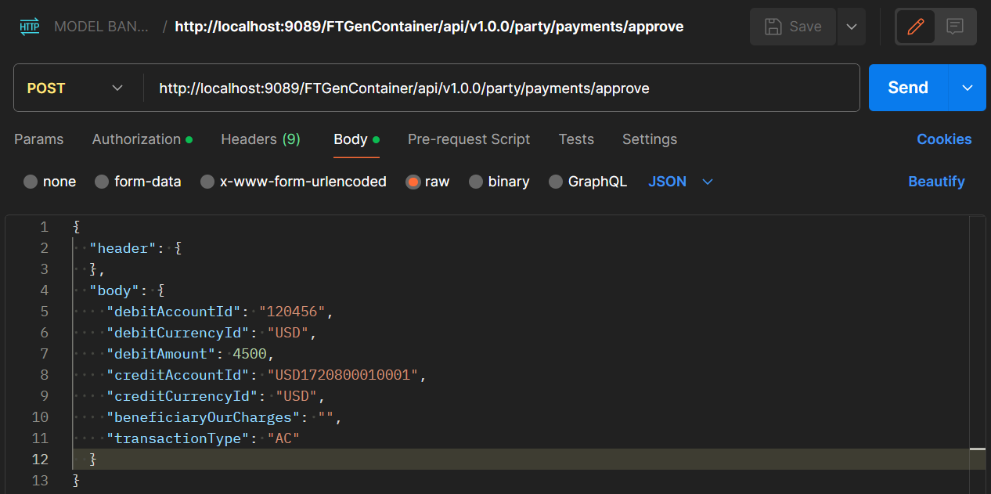

Body:

{

  "header": {

  },

  "body": {

    "debitAccountId": "120456",

    "debitCurrencyId": "USD",

    "debitAmount": 4500,

    "creditAccountId": "USD1720800010001",

    "creditCurrencyId": "USD",

    "beneficiaryOurCharges": "",

    "transactionType": "AC"

  }

}

**Response:**

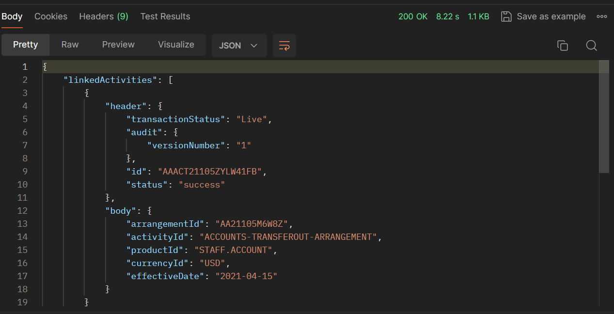

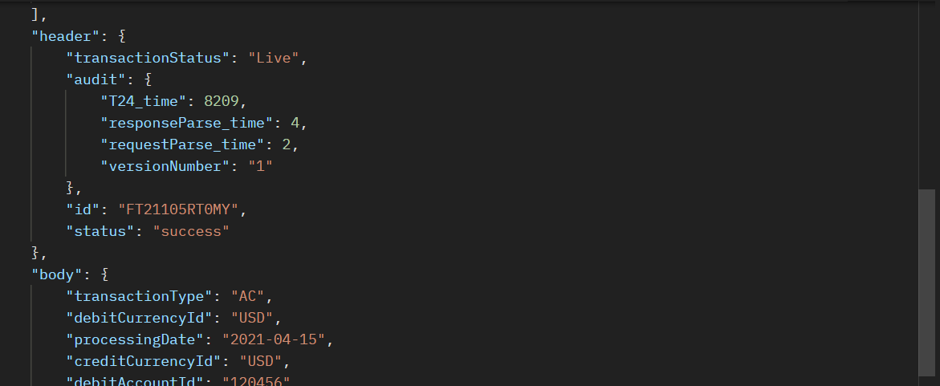

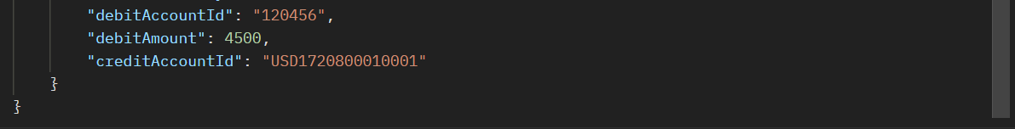

***Orchestration***

***Question***: Creating orchestration for FT and Account

***Requirement :*** After Authorization of FT(version), The enquiry which shows the debit Account Id’s Available balance

***Step 1:***

Choose the artefacts in the workbench and generate the zip file.

**Enquiry :** FUNDS.TRANSFER,FT.API.GENERIC.1.0.0

**Version :** PZ.API.ACCOUNTS.BALANCE.1.0.0

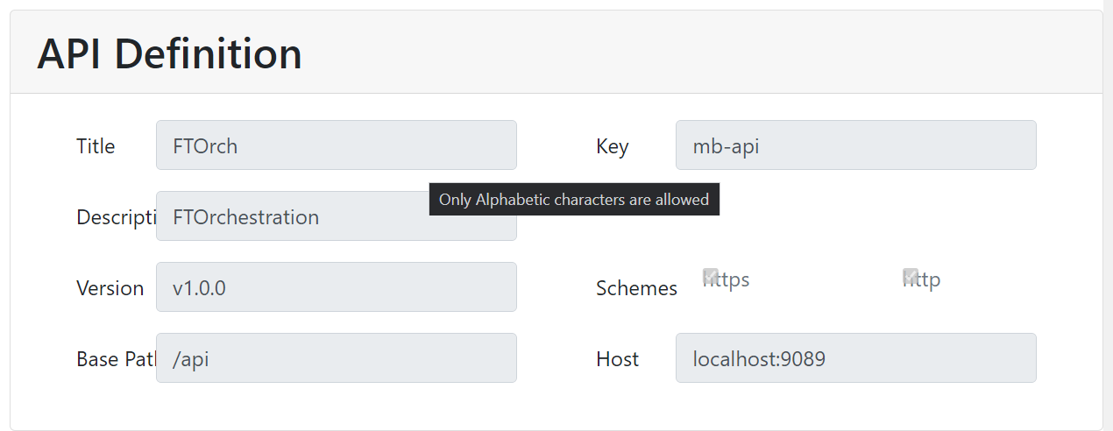

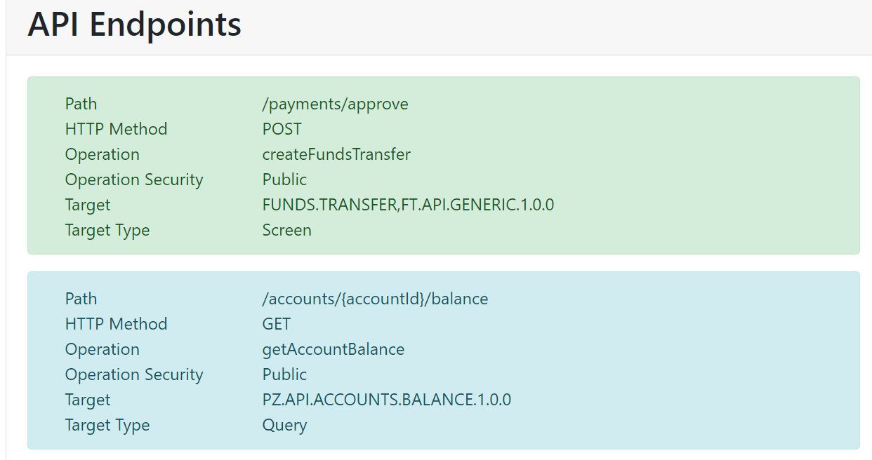

## Inventory

{

"paths": [

{

"method": "POST",

"url": "/party/payments/approve",

"function": "input",

"tags": [],

"operationId": "createFundsTransfer",

"operationSecurity": "Public",

"resources": [

{

"key": "FUNDS.TRANSFER,FT.API.GENERIC.1.0.0",

"resourceType": "Screen",

"consentManaged": false

}

],

"properties": {

"clientType": "INTERNAL",

"isBulk": false,

"deprecated": false

}

},

{

"method": "GET",

"url": "/party/accounts/{accountId}/balance",

"tags": [],

"operationId": "getAccountBalance",

"operationSecurity": "Public",

"resources": [

{

"key": "PZ.API.ACCOUNTS.BALANCE.1.0.0",

"resourceType": "Query",

"consentManaged": false,

"selections": [

{

"field": "ACCOUNTREFERENCE",

"param": "accountId",

"operand": "EQ",

"required": "",

"type": "string"

}

]

}

],

"properties": {

"clientType": "INTERNAL",

"isBulk": false,

"deprecated": false

}

}

],

"version": "v1.0.0",

"title": "FTOrch",

"description": "FTOrchestration",

"key": "mb-api",

"schemes": [

"http",

"https"

],

"basepath": "/api",

"host": "localhost:9089"

}

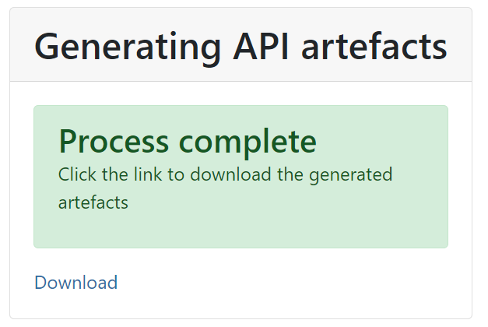

**Step 2:**

Extract the zip file and place it in the new service project.

src -> main -> resources

**Step 3:**

Open the service xml file in the project.

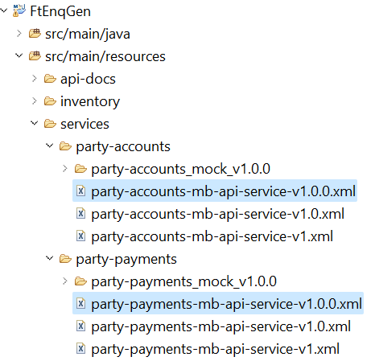

**Step 4:**

Open the **xml file** and write the below code under the **t24 VERSION** processor line in the xml file.

<choice>

<when>

<simple>${headers.CamelHttpResponseCode} == 200</simple>

<setHeader headerName = *"debitAccountId"* >

<camel:jsonpath>$.body.debitAccountId</camel:jsonpath>

</setHeader>

<to uri=*"* *direct-vm:party-accounts.v1.0.0.getAccountBalance"* />

</when>

</choice>

Above xml file is for **VERSION**. Here I am passing debitAccountId field to the **ENQUIRY** as selection field.

**Open the ENQUIRY** **xml file:**

Here we are Mapping the **debitAccountId** to the selection field. (Here we passing **headerName** which is written in the version xml file)

**Edit this line:** <constant>ACCOUNTREFERENCE EQ {debitAccountId}</constant>

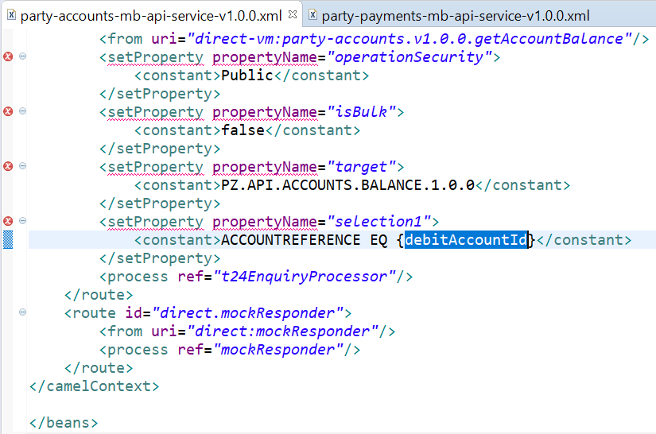

**Step 5:**

Right click on both project and Container **RunAs**-> Maven clean & Install.

**Jar file** is created in the **service project** & **war file** is created in the **container project**.

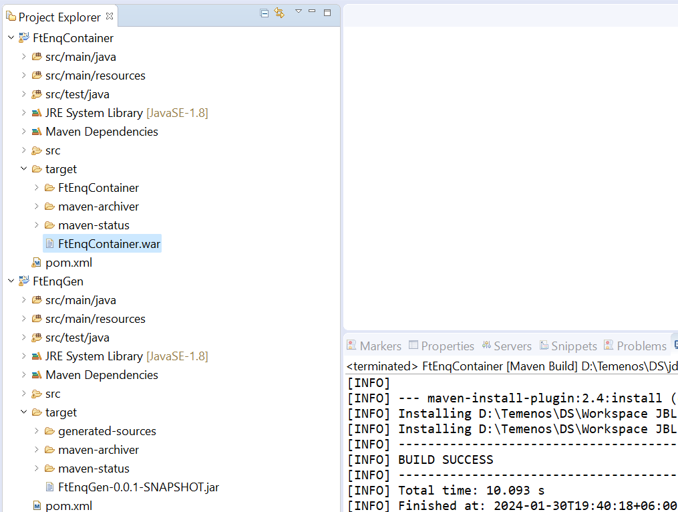

***Step 6:***

Deploy the war file in JBoss.

Add the server in the workbench.

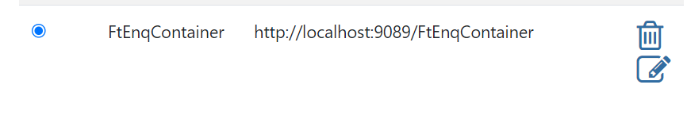

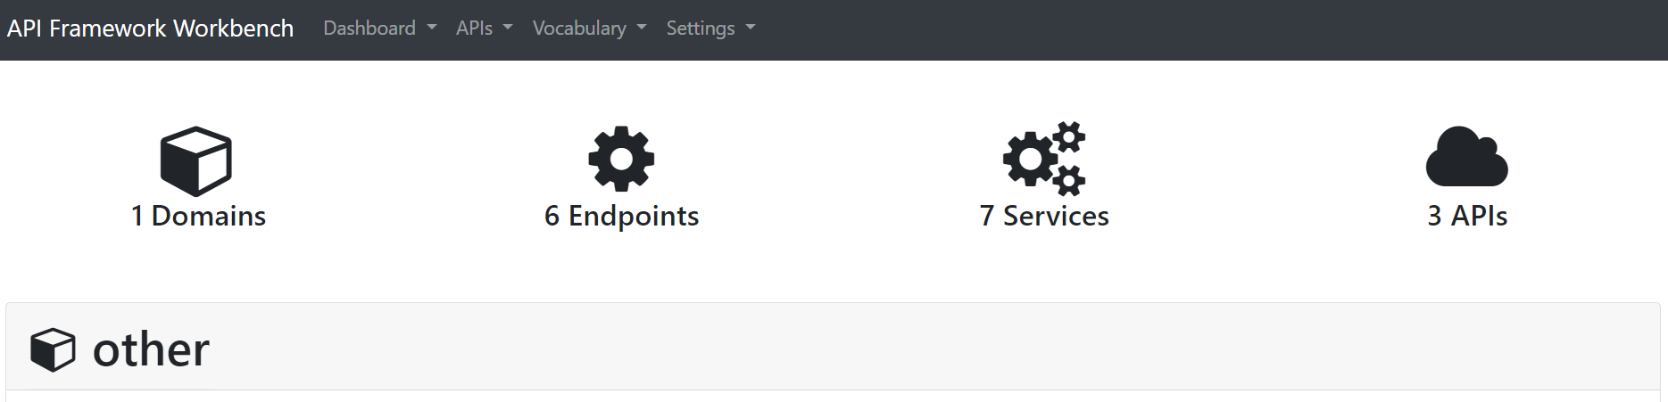 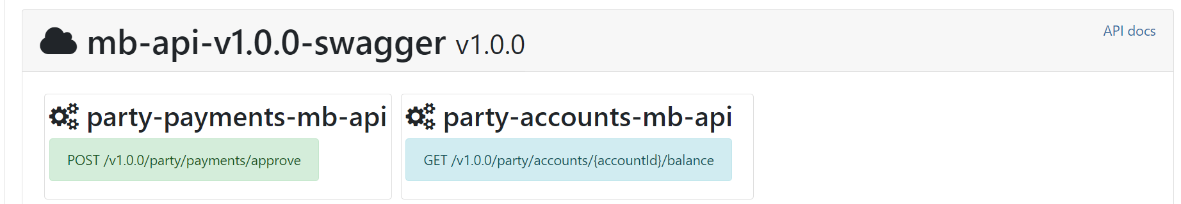

<http://localhost:9089/FtEnqContainer/api/v1.0.0/party/payments/approve>

**Special Note:** If Authorization issue occurs then we need to update the service xml

<setProperty propertyName="validate_only">

<header>true</header>

</setProperty>

<setProperty propertyName="userDetails">

<header>Authorization</header>

</setProperty>

<setProperty propertyName="function">

<constant>validate</constant>

</setProperty>

<process ref="t24VersionProcessor"/>

<choice>

<when>

<simple>${headers.CamelHttpResponseCode} == 200</simple>

<setHeader headerName="accountId">

<camel:jsonpath suppressExceptions="true">$.body.debitAccountId</camel:jsonpath>

</setHeader>

<setHeader headerName="Authorization">

<camel:exchangeProperty>userDetails</camel:exchangeProperty>

</setHeader>

<to uri="direct-vm:party-accounts.v1.0.0.getAcBalance" />

</when>

</choice>

</route>

***Step 7: Check it in POSTMAN***

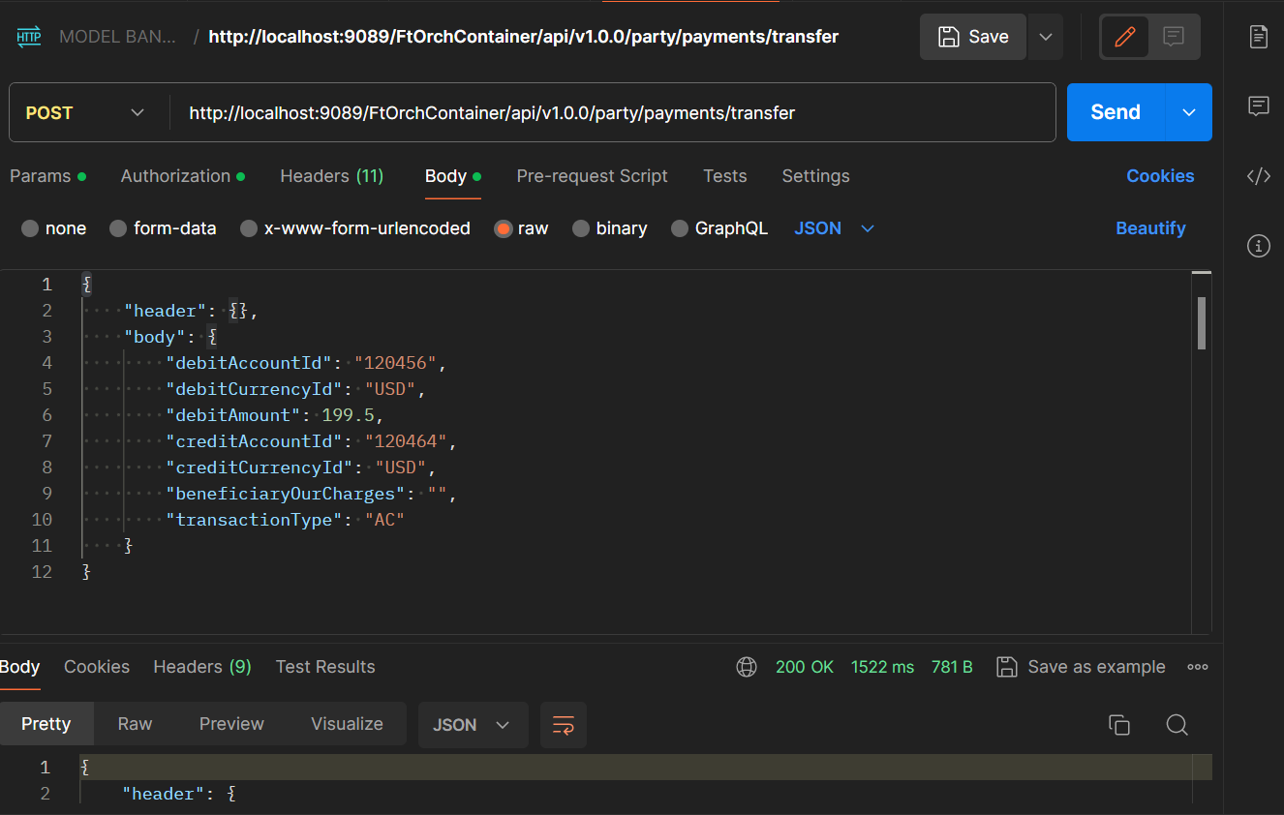

**Response:**

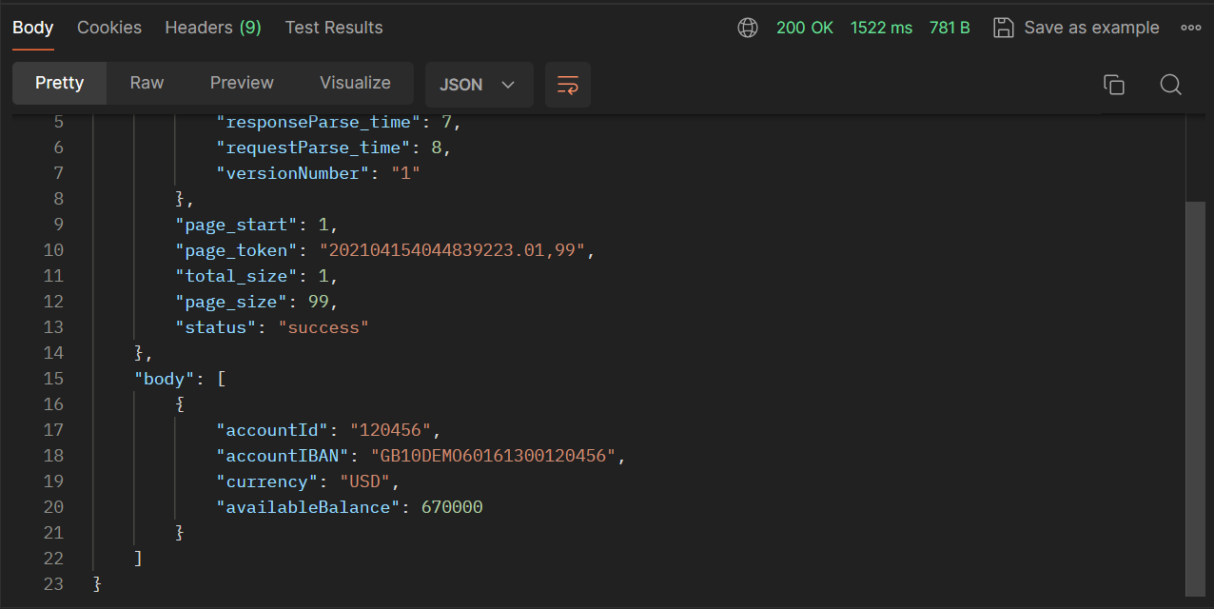

**XACML/ JWT Token**

**What is Xacml?**

Extensible Access Control Markup Language – Which is used for attribute based authorization.

For example, An API request must contain “**roleId**” as “**ADMIN**”. This **roleId** we can pass through headers or **JWT Token**.

**Xacml policy file will be available inside the container.**

**C:\Users\user\Downloads\irf-provider-container.war\WEB-INF\classes\xacml\**

**To Enable xacml: NO NEED TO ENABLE XACML if it’s JWT Only.** *Keep the* ***applicationContext.xml*** *as it is.*

Uncomment below line to enable **xacml**.



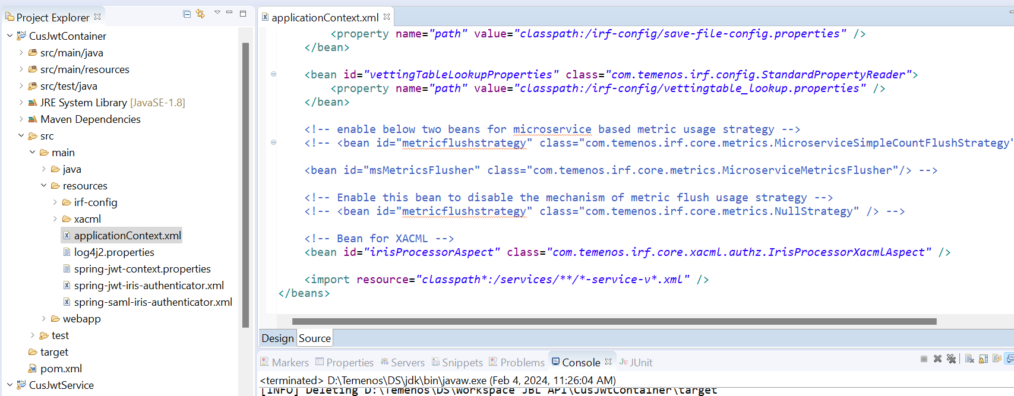



**IRIS Auth token Generation(JWT Only)**

The functionality required in IRIS is to provide capability in IRIS to **validate the credentials** passed in **header**(**Basic Authentication**) against T24 and send back the JWT token for successful authentication.

**Deploy** the war file **irf-auth-token-generation-container.war** in JBoss.

Check it in the postman by the below URL

**http://<host>:<port>/IrisAuthTokenGenerator/api/v1.0.0/generateauthtoken**

**irf-auth-token-generation-container-21.0.59.war**

http://<**host**>:<**port**>/**IrisAuthTokenGenerator**/api/v1.0.0/generateauthtoken

<http://localhost:9089/irf-auth-token-generation-container-21.0.59/api/v1.0.0/generateauthtoken>

**pass with credentials,**

**The Auth token has been generated.**

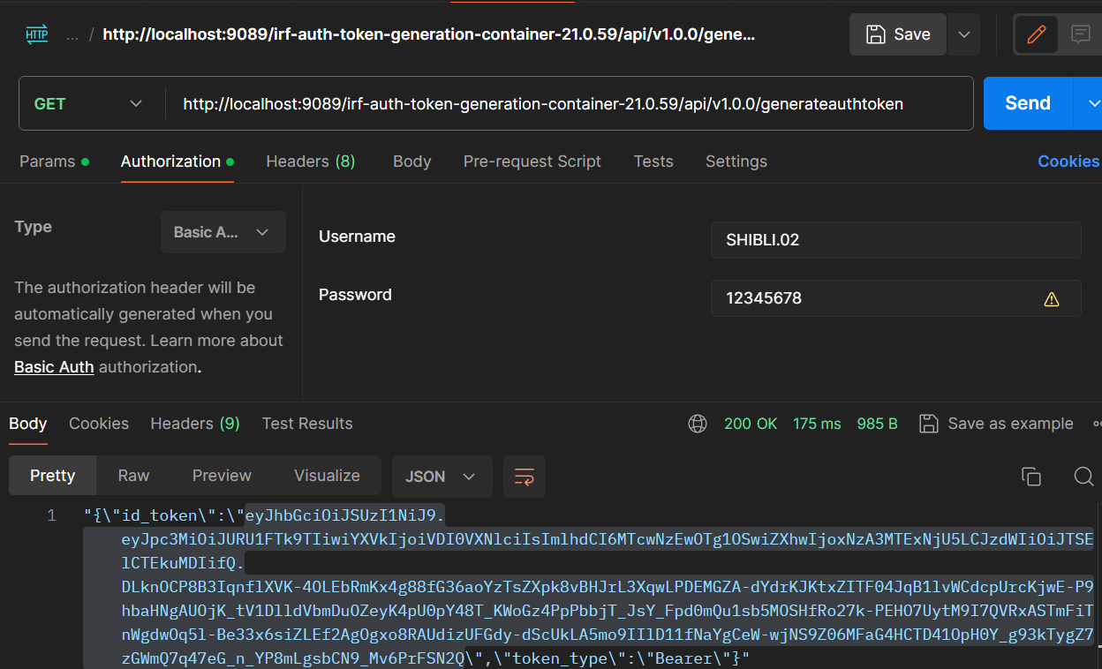

[**https://jwt.io/**](https://jwt.io/)

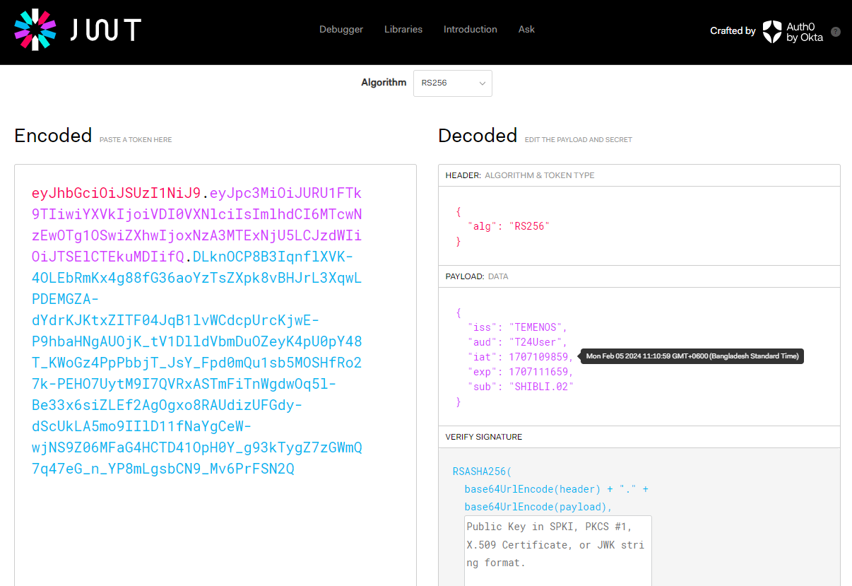

**To Enable JWT:**

UnComment below set of lines to enable JWT.

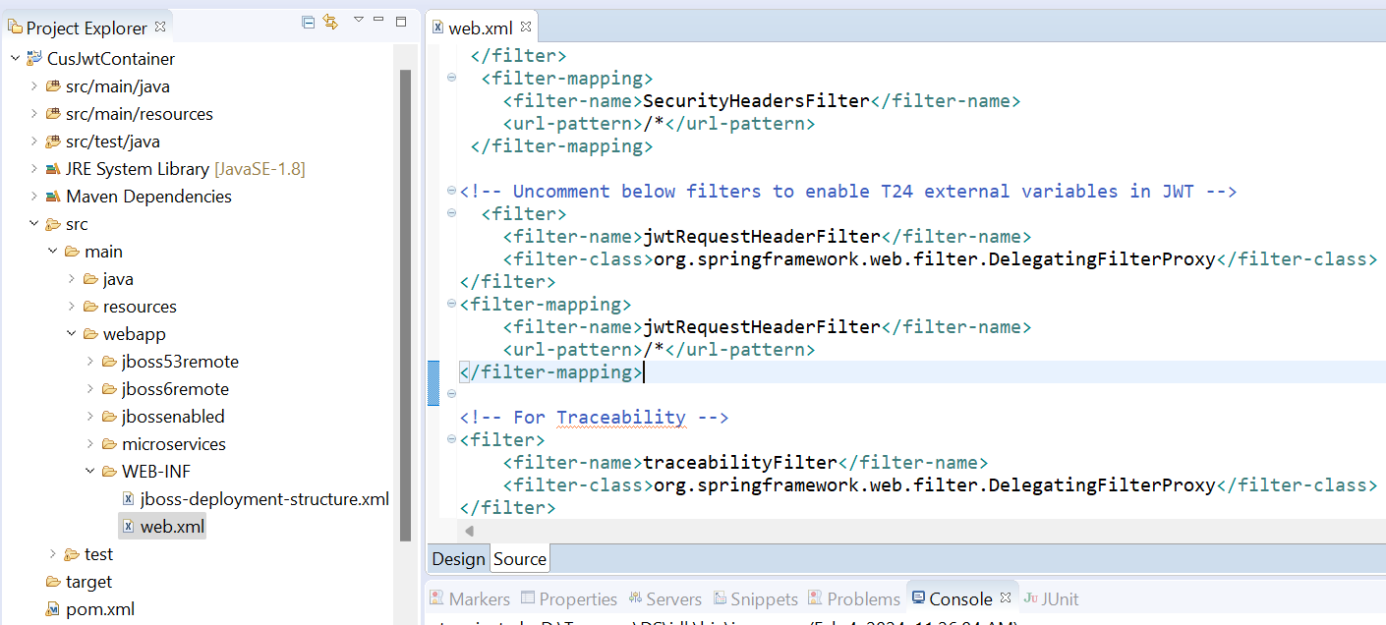



**Change spring-jwt-iris-authenticator.xml:**

Changed the OIDC provider issuer to TEMENOS if there is an issue with the provider like the SS below.

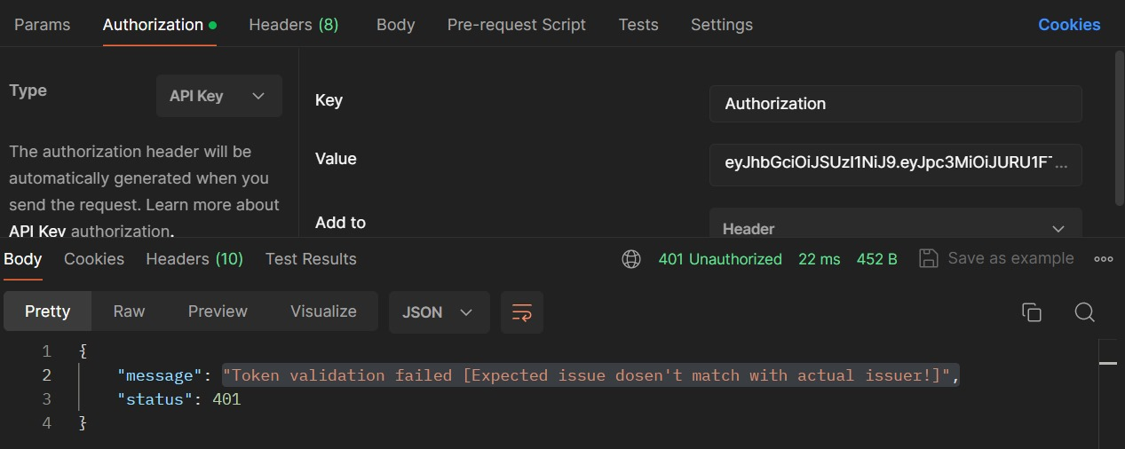

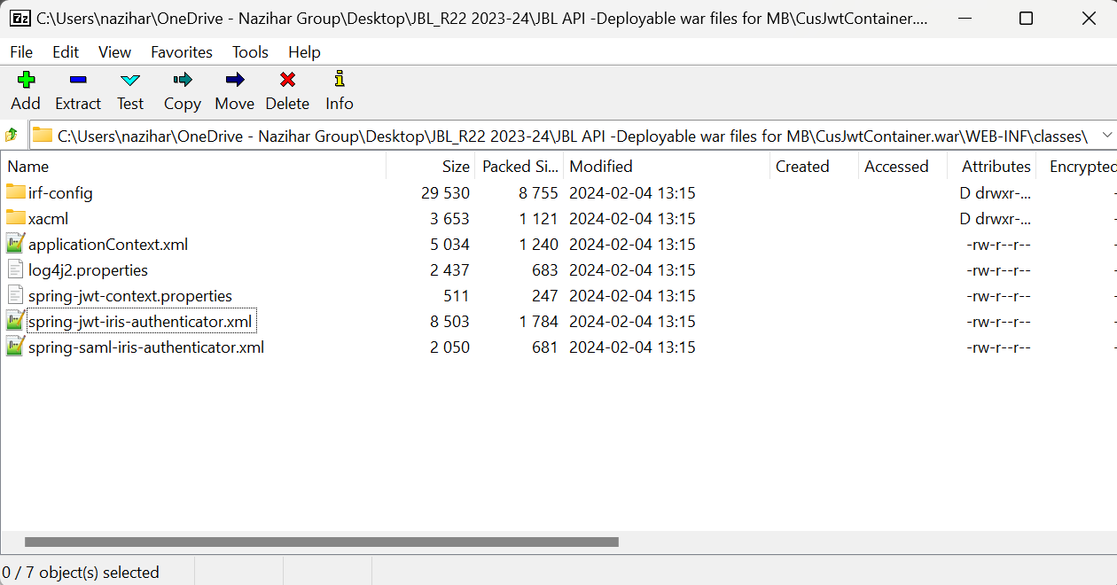

After changing the xml file it will look like this:

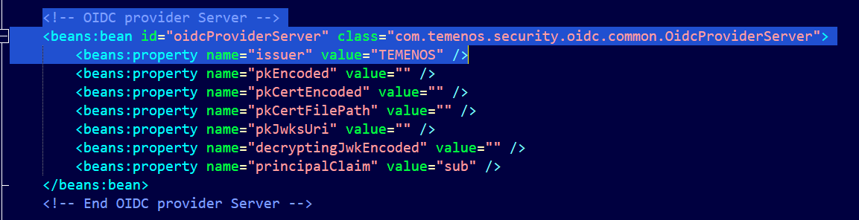

Now using **API Key,** the response is **OK** now.

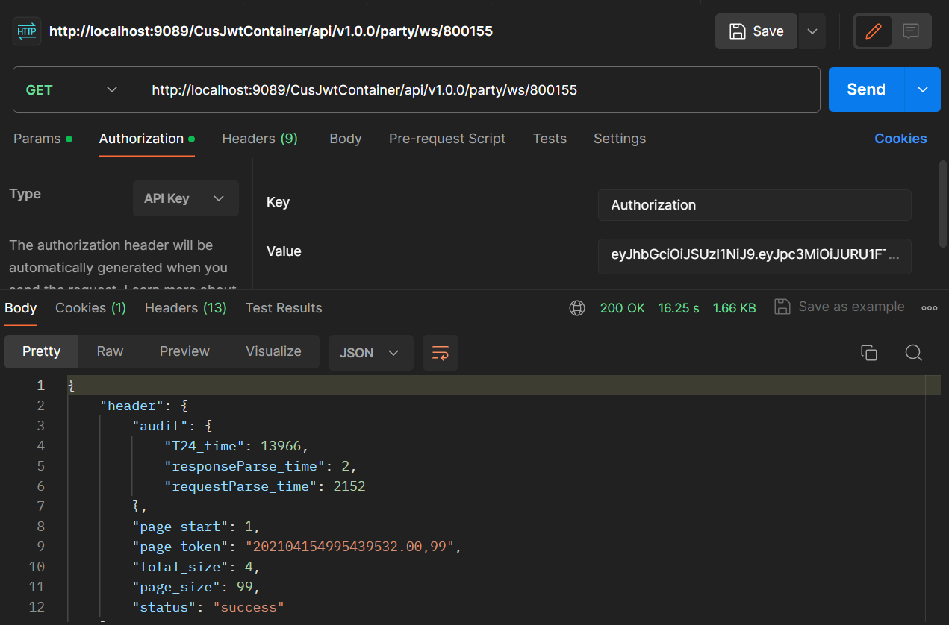

**Create JWT using Web tool(**<https://www.javainuse.com/jwtgenerator>**)**

